

April 2025
Social approach of DPAM
Implementing the UN Guiding Principles on Business and Human Rights
Contents

I. Adherence to human rights principles and the role of investors 2
1. Human rights 3
2. The investor’s duty to uphold human rights 4
3. Human rights governance 3
II. Embedding human rights in portfolio construction and due diligence 6
1. Controversial activities 8
2. Normative screening 8
3. Controversial behaviour 8
4. Positive screening 9
5. SDG alignment 9
6. Impact framework 9
III. Continuous human rights due diligence across DPAM assets 10
1. High-risk sectors 11
2. Identifying at-risk companies in high-risk sectors 11
3. Extended human rights analysis 12
IV. Advancing human rights within investee companies and issuers 14
1. Engagement 15
2. Engagement partners 15
3. Voting 16
V. The special case of sovereign investments 17
VI. Transparency and disclosure 20

- Adherence
to human rights principles and the role of investors



Human rights
Human rights are fundamental rights and freedoms that belong to every person, regardless of nationality, sex, ethnicity, religion, or any other status. They are inherent, inalienable, and universal. The Universal Declaration of Human Rights, adopted by the United Nations General Assembly in 1948, was the first international document that enshrined the rights and freedoms of all human beings. Since then, the United Nations has gradually expanded human rights law to encompass specific standards for women, children, people with disabilities, minorities and other vulnerable groups, who now possess rights that protect them from discrimination.
DPAM commits to respect:
- The International Labour Organization’s (ILO) core conventions
- The International Bill of Rights
- The UN Global Compact
- The UN Guiding Principles on Business and Human Rights



Human rights governance
This policy is ratified by our Board. The oversight of this policy is carried out by the SRI Steering Group that convenes once a month. The SRI Steering Group reports directly to the Management Board of DPAM, under the oversight of DPAM’s Board of Directors.
The integration of Environmental, Social & Governance (ESG) factors is the shared responsibility of the investment professionals at DPAM including portfolio managers, fundamental analysts and responsible investment specialists.
The integration of human rights in portfolio construction and continuous human rights due diligence across DPAM assets, in addition to advancing human rights within investee companies and issuers, is led by the Responsible Investment Competence Centre, in close collaboration with other investment professionals; the risk department is also vital.



The investor’s duty to uphold human rights
DPAM is committed to respecting internationally recognised human rights across its investment activities. To do so, it follows the OECD Guidelines for Multinational Enterprises and the UN Guiding Principles on Business and Human Rights (UNGPs). We consider that we have our predominant effect on human rights through our investments.
Our activities, as an investor, can be linked to human rights outcomes by the actions taken by the companies or issuers we invest in.
In many countries, human and labour rights exist more in theory than in practice. Weak legal frameworks leave these rights unprotected, while governments—whether hamstrung by scarce resources or unwilling to act—often fail to enforce them. In such environments, some companies exploit regulatory gaps, driving down wages below legal minimums or disregarding fundamental labour protections, including bans on child and forced labor. This can happen not only within their own operations but also through the neglect of abuses within their supply chains. Human rights infringements are naturally not limited to companies active in countries with weak legal frameworks.
In addition to negatively impacting workers in their direct operations or supply chains, companies might harm human rights through their products and services. With rapid technological advance, companies might cut corners when it comes to digital rights, including privacy and freedom of expression. These adverse human rights impacts, through products and services, are not limited to the IT sector, as certain products might have significant negative repercussions for users, for example harmful medicines from pharmaceutical companies or infrastructure companies with insufficient quality controls.
Finally, companies can have a significant impact on local communities through their supply chain or when carrying out their operations. One example of how a company might impact a local community via its supply chain, might be through the extraction of mineral sources that pollute a local population’s habitat. An example of a direct impact through a company’s operations could be a renewable energy company placing its assets in the territory of indigenous peoples, without adopting a proper due diligence approach.
These examples illustrate that adverse outcomes can be linked to the supply chain of the investee companies, their direct operations, or through the use of their products and services. DPAM’s commitment to human rights applies to the adverse impacts that we may cause directly through our investments, and to the human rights impacts that the companies or entities in which we invest may cause, may contribute to, or be directly linked to, through their own operations or business relationships.
When we observe an investee company that is linked to, contributes to or is causing an adverse human rights impact, it’s our duty to use our leverage on the investee company to prevent or mitigate the adverse impact and to enable a remedy for the affected stakeholders. We align with the UNGPs and the OECD Guidelines for Multinational Enterprises, believing engagement is more effective than divestment in driving change. However, as a last resort, we will exclude investments if our efforts to influence behaviour fail—considering the severity of the human rights impacts, the company’s response, and potential adverse effects of divestment.
The figure below showcases the decision tree we use when facing an adverse human rights impact by an investee company or issuer.

Decision Tree
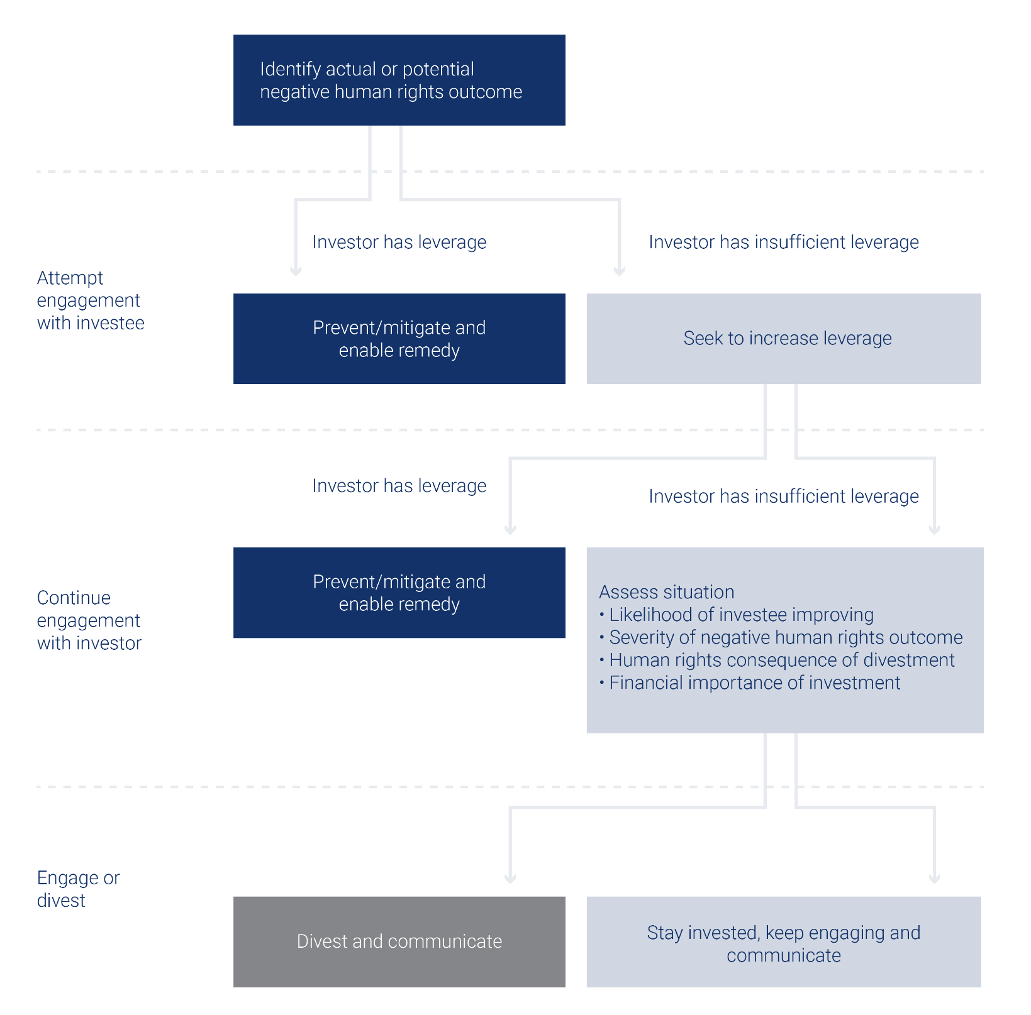

- Embedding human rights in portfolio construction and due diligence
DPAM carries out several ESG screening steps for its investment funds These steps are described in DPAM’s sustainable and responsible investment policy. The actions that DPAM undertakes in its human rights due diligence depend on the type of investment fund. This chapter delves into the pre-investment checks that take place to avoid us investing in companies that infringe human rights too severely. Ample information on these investment steps can be found in our Sustainable and Responsible Investment policy.

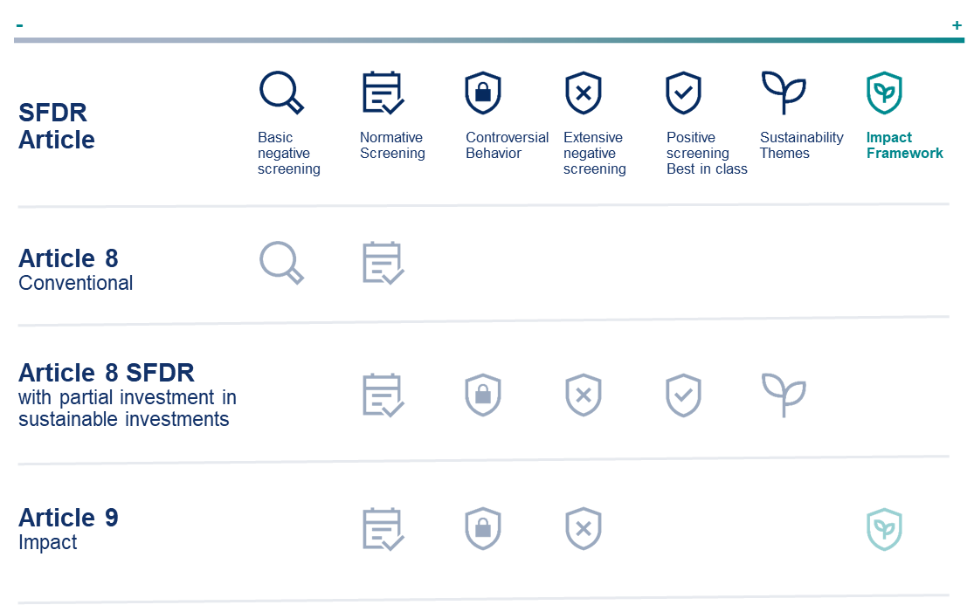



Controversial activities
DPAM considers that some business activities should be excluded from its investment universe, as they pose an unacceptably high risk for adverse human rights impacts. For companies involved in certain activities, we consider that it is impossible that they can realistically shift towards activities that positively contribute to a sustainable economy. The activities range from specific defence activities to tobacco production. In addition to so-called hard exclusions, the policy also describes at-risk activities that necessitate additional scrutiny, examples include companies producing palm oil which necessitates a minimum amount of external certification, to prevent adverse biodiversity and human rights impacts.



Normative screening
DPAM does not invest in companies that are in severe breach of the global standards, including the UN Global Compact Principles, the UN Guiding Principles, and the ILO core conventions. To ensure that no exposure happens in our article 8 and 9 funds, DPAM relies on two data providers that ensure compliance. In case one or two providers consider a company to be in breach, these funds can no longer invest in the company. This careful approach ensures that DPAM does not invest in companies that are in breach of international standards, according to the market.

Controversial behaviour
The controversial behaviour review prevents investment in companies that face significant controversies related to, among others, human rights. An automatic exclusion takes place for companies having a controversy level of 5 on a scale from 0 to 5. Companies with a score of 4 or 3 with a negative outlook, are systematically discussed in the SRI Steering Group. These discussions amount to either rendering the company eligible, excluding it or launching an official engagement.
Other than these systemic controversial behaviour reviews, we also analyse the ad hoc controversial behaviour of investee companies if we deem that they might have a severe adverse impact on human rights. These ad hoc controversial behaviour reviews of a single company might bring to light systemic human rights infringements by a whole sector or activity, which leads to a systemic human rights review of that issue. Examples in the past were, the opioid crisis or the Occupied Palestinian Territories.



Positive screening
At the positive screening stage we ensure that our 8 SFDR with partial investment in sustainable investments and 9 investment funds do not invest in companies or issuers that score badly on material ESG-risks compared to its industry or subindustry peers. This comparison is carried out based on a double materiality principle. Salient human rights are also reviewed in this process, when material. The way this positive screening is carried out depends on the individual funds and can focus on quantitative best-in-class at the (sub)-industry level or qualitative scorecards.



SDG alignment
A sustainable financial investment pursues an environmental and/or social objective. An investment is considered to have an environmental and/or social objective if it pursues an environmental objective linked to the six objectives set out in the Taxonomy or if it contributes to one of the UN’s Sustainable Development Goals (SDGs). Moreover, use-of-proceeds instruments are also recognised as sustainable instruments, these include among others, social bonds, sustainability bonds, or sustainability-linked bonds.



Impact framework
For impact funds, issuers are mapped using the DPAM Sustainable Impact Themes framework. This is a list of nine defined sustainable impact themes, divided into more than fifty subthemes. The impact analysis requires that companies achieve a significantly net positive impact alignment, measured through defined KPIs for each subtheme:
- At least 30% net positive impact-related revenue
- Or at least 50% impact-related CapEx or R&D
- Or at least 50% net positive alignment of its activity, defined on the basis of the company or on sector specific KPIs, focusing on the products or services sold.

- Continuous human rights due diligence across DPAM assets



High-risk sectors
To enhance and bolster our assessment of human rights risks, DPAM has established a social approach to identify sectors at higher risk for human rights infringements. There is no official mapping regarding the sectors, industries, or activities where salient human rights issues are widest in scope, scale and in terms of difficulty for remediation. However, the European Union Agency for Fundamental Rights, the OECD, the US Department of International Labor Affairs and the UN Human Rights Office highlight the industries or sectors that are particularly vulnerable to human rights infringements, namely:
- Extractives and natural resources
- Agriculture and food production
- Infrastructure and construction
- Textile and garment
A focus on these industries is therefore the starting point of any due diligence exercise on human rights infringements. Nevertheless, at DPAM, we decided to also look at potential human rights infringements on a forward-looking basis, anticipating breaches of human rights due to technological advances. That is the reason why we also include digital rights as a key focus. Therefore, the list of industries is subsequently broadened with following industry:
  - Digital platform and telecommunication companies



Identifying at-risk companies in high-risk sectors
Identifying companies within these sectors is key. We identify potential severe human rights breaches through an ex-post analysis (after a human right infringement has taken place), and an ex-ante analysis when companies lack proper human rights due diligence (when a company is likely to face a human rights infringement due to lacking management practices).
This analysis is based on several steps, mainly:
- A social controversy ranked by our data provider above 2 (on a scale from 0 to 5);
- Ranking in the bottom 40% of the human rights analysis of the World Benchmarking Alliance’s Social Benchmark;
- Ranking in the bottom 20% of one or more industry-specific ranking;
- Specific NGO reporting on Conflict Affected and High-Risk Areas (CAHRAs).



Extended human rights analysis
For companies flagged as being at-risk in a high-risk sector, we will conduct an extended human rights analysis. The analysis focusses on two elements:
First, a deep dive into the reason why the company was flagged, be it either a controversy or a lack of disclosure and processes. Second, with the help of the Shift red flag methodology and aided by external rankings, the analysis considers whether a company effectively handles a controversy or if it should improve its business practices on due diligence. The Shift red flag methodology is a set of indicators (red flags) that may be found in a business model which indicates a heightened risk of human rights infringement. For each red flag, the Shift has a guidance document with best practices, the tangible application of the UNGPs and a list of engagement questions for companies.
DPAM’s analysis also focusses on distinct stakeholder groups that can be affected. Upstream workers, workers in operations, buyers and users, and community relations in the value chain.
After the analysis, DPAM can conclude if:
- The company’s human rights risks are properly managed by the company
- The company’s human rights risks are not properly managed by the company, an official engagement is needed
- The company’s human rights risks are not properly managed by the company and therefore divestment is warranted

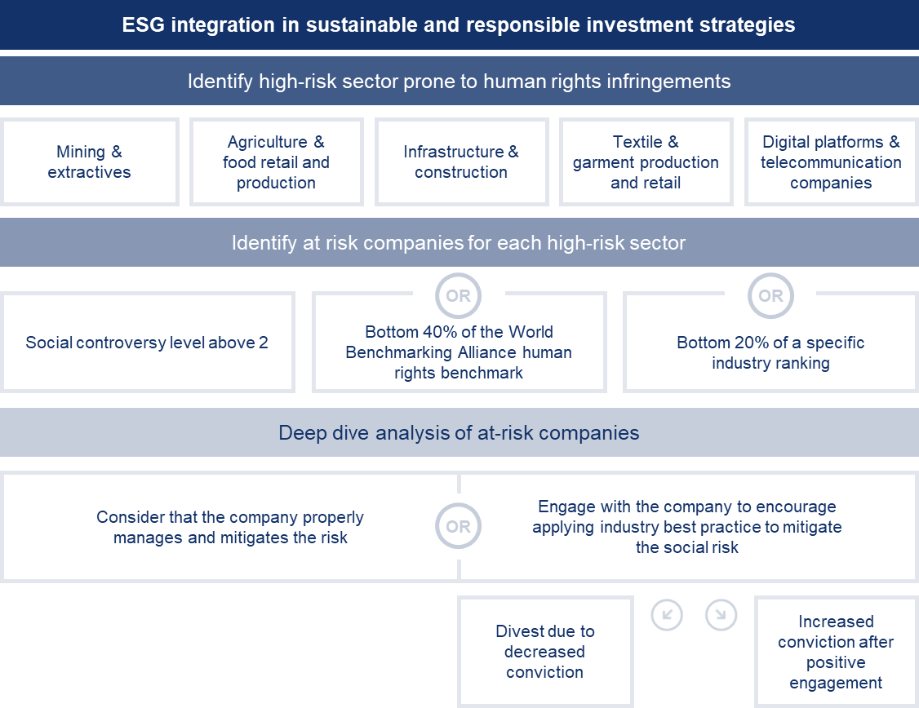

- Advancing human rights within investee companies and issuers
We believe engagement is more effective than divestment in driving change. However, as a last resort, we will exclude investments if our efforts to influence behaviour fail. The different steps that we take in our engagements, are described in the escalation policy of our engagement policy.

Engagement
DPAM has defined digital rights, due diligence on social risks in supply chains, conflict-affected and high-risk areas, and workers’ representation as the focus topics to represent our social convictions. Our engagement policy provides more details on these topics, the means that we have to conduct these engagements, and the expectations that we have for our investee companies or issuers.
Naturally, DPAM also engages with companies flagged through its ‘continuous human rights due diligence’ described in chapter III or its controversial behaviour review, described in chapter II of this policy.



Engagement partners
As depicted in on the graph on page 5 seeking to increase leverage is key when identifying an adverse human rights impact in an investee company. Therefore, DPAM partners with co-investors and civil society actors to target companies in its engagement activities. Below you will find a short overview of the social collaborative initiatives which DPAM takes the lead in or supports.
- The World Benchmarking Alliance – CIC Ethical AI: The Collective Impact Coalition for Ethical Artificial Intelligence is a coordinated engagement campaign aiming to push technology companies to advance ethical AI policies and practices. It is led by the World Benchmarking Alliance
- The Investor Alliance for Business and Human Rights - The Corporate Human Rights Benchmark (CHRB): The CHRB provides a comparative snapshot of the largest and most influential companies in high-risk sectors, looking at the policies, processes, and practices they have in place to systematise their human rights approach and how they respond to serious allegations. The Investor Alliance for Business and Human Rights, assists a group of investors in targeting companies to improve their scores on the CHRB.
- Principles of Responsible Investments (PRI) – Advance: Advance is a PRI-led collaborative stewardship initiative on human rights and social issues. For now, the initiative focusses on utility and mining companies.
- Heartland Initiative and PeaceNexus: Both organisations have a deep knowledge of peace finance, and CAHRA and together with both partners, we have worked on a guide on CAHRA. Additionally, they assist us when we need technical expertise in their knowledge areas.



Voting
DPAM fully supports shareholder and management ESG-related proposals. DPAM will defend its key priorities, notably human rights in the supply chain and data privacy. Other social performance indicators will also be taken into account when voting. These indicators cover a broad range of topics, including:
- Diversity at the company level and different management and executive levels, including the Board of Directors, executives, senior leadership, managers, and other leaders (e.g. DPAM expects companies to have at least 1/3 of the underrepresented gender in its board of directors);
- Pay equality between women and men, with DPAM supporting best practice to close the gender pay gap;
- Employee retention and turnover, which are considered good indicators of a company’s organisational success, among other metrics;
- Employee training and coaching to build critical skills, increase knowledge, and become familiar with local ways of working; and
- Health and safety metrics such as workplace injury rates, especially when analysing industrial companies; or
- Any other shareholder proposal aimed at safeguarding human rights.
We also steer our voting instructions based on the Corporate Human Rights Benchmark by the World Benchmarking Alliance (WBA). This benchmark receives an annual update and covers 200 companies. We consider pillar B2 of the analysis to be key, which focusses on human rights due diligence processes. These processes serve as the leading indicator for preventing major controversies and ensuring compliance with global standards. Hence, we will vote against the CEO/Chairman of the board and/or other relevant agenda items if the company scores a 0 on pillar B2 of the Corporate Human Rights Benchmark analysis.
The WBA will change the scope of the Corporate Human Rights Benchmark and will carry-out a more in-depth analysis of its Social Benchmark. Therefore, DPAM will likely use the due diligence section of the Social Benchmark in the future.
Finally, DPAM’s voting instructions can be used as a means of escalation in its engagement policy. Indeed, among the escalation steps that DPAM can undertake, it can vote for specific resolutions or against the re-election of directors. The different escalation steps that can be used during formal engagements, are described in our engagement policy.

- The special
case of sovereign investments

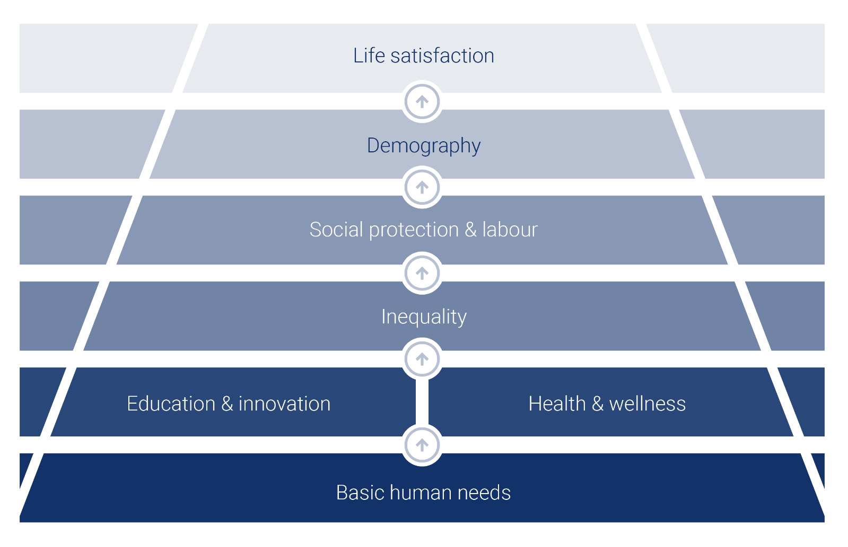
Framework of the social dimension of DPAM’s country model

Our adherence to human rights goes beyond our corporate investments, but also includes our exposure to sovereign issuers. Our proprietary sustainable country model, the foundation of our sustainable sovereign investment funds, consists of three pillars, one being the social pillar. This pillar evaluates countries based on two key areas: Education & Innovation and Population, Healthcare & Wealth Distribution. Each area is broken down into several themes, which are further composed of specific indicators to capture performance in a detailed and structured way.
We identified a hierarchy of key social themes, from Basic Human Needs to Life Satisfaction, which we now use as a structural framework in the model. This pyramid illustrates how each social dimension builds upon the previous one.
Our model remains aligned with the Brundtland Report (1987) definition of sustainable development, which emphasises meeting the needs of the present generation — represented by Population, Health, and Wealth Distribution — and those of future generations, captured through Education and Innovation.
Starting from the bottom of the pyramid - the basis of the model - basic human needs is considered as the most important element, followed by education and health, which open the door to more equality, social protection and labour. These, in turn shape a more efficient demographic structure, ultimately leading to higher life satisfaction.
Each level of the pyramid is essential and supports the one above it. It is important to note that we do not invest in countries which are deemed non-free and non-democratic, as we believe that even with engagement, our leverage will not be significant enough to remedy the adverse human rights impact of that sovereign issuer.
In addition to being the building block for investment, our proprietary sustainable country model, is also the basis for engaging with sovereign issuers. As a sustainable partner, focused on making an impact, we engage in dialogue with countries to explain our role as a key intermediary in the value chain. This can be a way of promoting a sustainable agenda to different sovereigns’ representatives. Our country model is at the forefront of our dialogue with sovereigns where we highlight relative national strengths and weaknesses.
The aim of these meetings is not to elaborate on the sustainable country model, but rather to explain how the output of the model works and we enter into dialogue with different countries in order to:
- Explain our approach and how it may impact our investment decision process.
- Raise awareness about the outcome of our model and to ultimately pass on a clear message to policy makers that country sustainability can be a key driver for investor appetite.
- Be receptive to any constructive feedback to enhance our models.

- Transparency and disclosure
We publish this policy on our website. We also provide annual reports on our voting and engagement activity, which include sections on human rights and social issues. Both reports describe the priority areas of engagement and voting, as well as the key voting and engagement trends of the year.

0





Contact
Details
Responsible Investment Competence Center
Ricompetencecenter
@degroofpetercam.com
ricompetencecenter@degroofpetercam.com

www.dpaminvestments.com
/company/dpam
dpam@degroofpetercam.com
www.dpaminvestments.com/blog

Disclaimer
The information contained in this document and its attachments (hereafter the “documents”) is provided for pure information purposes only.
These documents do not represent an investment advice and do not form part of an offer or solicitation for shares, bonds or mutual funds, or an invitation to buy or sell the products or instruments referred to herein.
Applications to invest in any fund referred to in this document can only validly be made on the basis of the key investor information document (KIID), the prospectus and the latest available annual or semi-annual reports. These documents can be obtained free of charge from Degroof Petercam Asset Management sa, the financial service provider and on the website of the sub-fund at www.dpamfunds.com.
All opinions and financial estimates herein reflect a situation on the date of preparation of these documents and are therefore subject to change at any time without prior notice. Specifically, past performance is not necessarily indicative of future performance and there is no guarantee it will be repeated.
Degroof Petercam Asset Management nv (DPAM), with registered office at Rue Guimard 18, 1040 Brussels, and which is the author of the present document, has made its best efforts in the preparation of this document and is acting in the best interests of its clients, yet without carrying any obligation to achieve any result or performance whatsoever. The information provided is from sources which DPAM believes to be reliable. However, DPAM does not guarantee that the information is accurate or complete.
These documents may not be duplicated, in whole or in part, or distributed to other persons without the prior written consent of DPAM. These documents may not be distributed to retail investors and are solely restricted to institutional investors.
DPAM sa - Rue Guimard 18 | 1040 Brussels | Belgium

