2023
TCFD Report

Reporting in accordance with the task force on Climate-Related Financial Disclosures & Net Zero Asset Managers Initiative
October 2023
Contents
I. Executive summary 4
1. State of affairs 4
II. Preamble 7
1. DPAM, an experienced sustainable investor 7
2. Climate change risks continue to increase within a challenging macro-economic and (geo)political environment 7
3. Integrating climate change factors: DPAM’s fiduciary duty and ambition for continuous improvement 10
III. Implementing the TCFD recommendations: Intro 12
1. Objective of the TCFD recommendations 12
2. DPAM’s approach 13
3. From TCFD to GFANZ 14
IV. Governance 16
V. Strategy & risk management 18
1. Linking climate change and DPAM’s investment activities 18
VI. Metrics & Targets 49
1. Metrics: increasing our reporting capabilities, aligned and beyond regulatory requirements 49
2. Targets: SFDR, Controversial Activities, and the road to Net Zero 51
VII. A process of continuous improvement 55
1. Looking back: some first milestones achieved 55
2. Looking forward: further improving our climate-related risk management techniques 57
VIII. Integrating the TNFD principles 58
1. Biodiversity loss in the spotlight of investors and regulation 58
2. DPAM’s commitment to adopt the TNFD recommendations 59
2.1 Governance 61
2.2 Strategy and Risk Management 61
2.3 Metrics and Targets 62
IX. Annex 63
1. Annex I: TCFD recommendations (4 pillars) 63
2. Annex II: TCFD Steering Committee description 64
2.1 Intro 64
2.2 Members 64
2.3 Roles & Responsibilities 64
2.4 Annex III: TCFD risk and opportunities framework (link climate change and finance) 65
3. Glossary 66


- Executive summary

- State of affairs
2023 was yet another challenging year in relation to climate change. Again, several significant physical climate events hit thousands of people, ranging from devastating floods in Libya, Australia and Europe, to droughts and wildfires in Greece, Chile and wider Asia. At the same time, geopolitical tensions, inflation and supply chain bottlenecks impacted the transition towards a low-carbon economy, while COP28 was considered historical by some.
All these events significantly impacted economic activities and investors worldwide. Furthermore, they might increase the likelihood of delayed, disorderly policy responses. To mitigate climate risks and contribute to the transition as a financial institution, DPAM initiated the implementation of the TCFD recommendations in 2019. In 2023, we enhanced our approach and integrated climate-related risks and opportunities to a greater extent in our investment decision making processes. This includes assessing both the climate alignment of our investments from a values perspective (i.e. linking our NZAM commitment) as well as transition alignment from a value perspective (i.e. linking the impact of corporate targets and target achievement on shareholder value creation).
On all levels, from governance to metrics and targets, we continued our efforts to identify areas for improvement based on best practice and internal research. From a governance and policy perspective, we continued our dedicated online and in person training on various climate topics, both for internal and external audiences, ranging from TCFD recommendations and climate risk assessments at issuer level, to Net Zero. Furthermore, we continued our efforts to enhance our voting (escalation) policy and prepared for upcoming Climate Resolutions or so-called Say-on-Climate votes. Our existing framework with follow-up via formal engagement letter, detailing our voting behaviour and considerations, was revised for the 2024 voting season. On the research side, we continued our approach of assessing the most carbon emitting positions in our investment portfolios, enhanced the assessment template to focus more on corporate transition planning, and enhanced the implementation of our process for formal outcome reviews and follow-up. Furthermore, our voting escalation was revised and finetuned.
From a risk management perspective, throughout 2023 we enhanced our TCFD Dashboard to assess risk and opportunities exposure at DPAM level by integrating additional data sources such as target credibility ratings and performance (trend) data, which also provides additional insights into Net Zero target tracking.
To conclude, on the metrics and targets front we set up the required tools and procedures to meet the SFDR reporting obligations, which include disclosure on climate-related principle adverse impact indicators. From a target setting perspective, we implemented monitoring tools to track our Net Zero commitment at DPAM level and portfolio-linked Net Zero target setting. Furthermore, note that all SFDR-classified article 8+ or 9 funds include a climate-related KPI (target) in their investment approach.
Note that the report covers our scope 3 financed emissions, consistent with the sector-specific net-zero alliance commitments, as these are significantly larger than our operational scope 1 and 2 emissions. For the latter, we refer to Bank Degroof Petercam SA/NV’s non-financial report.
2023 has been characterised by an increased focus on Biodiversity, among other initiatives, such as Nature Action 100+ and aligning with the Task force on Nature-related Financial Disclosures. Both emerged from climate-related concepts, respectively CA100+ and TCFD. As a sustainable and responsible investor, throughout 2023, DPAM has been exploring its approach towards the increasingly prominent topic of integrating the TNFD principles.

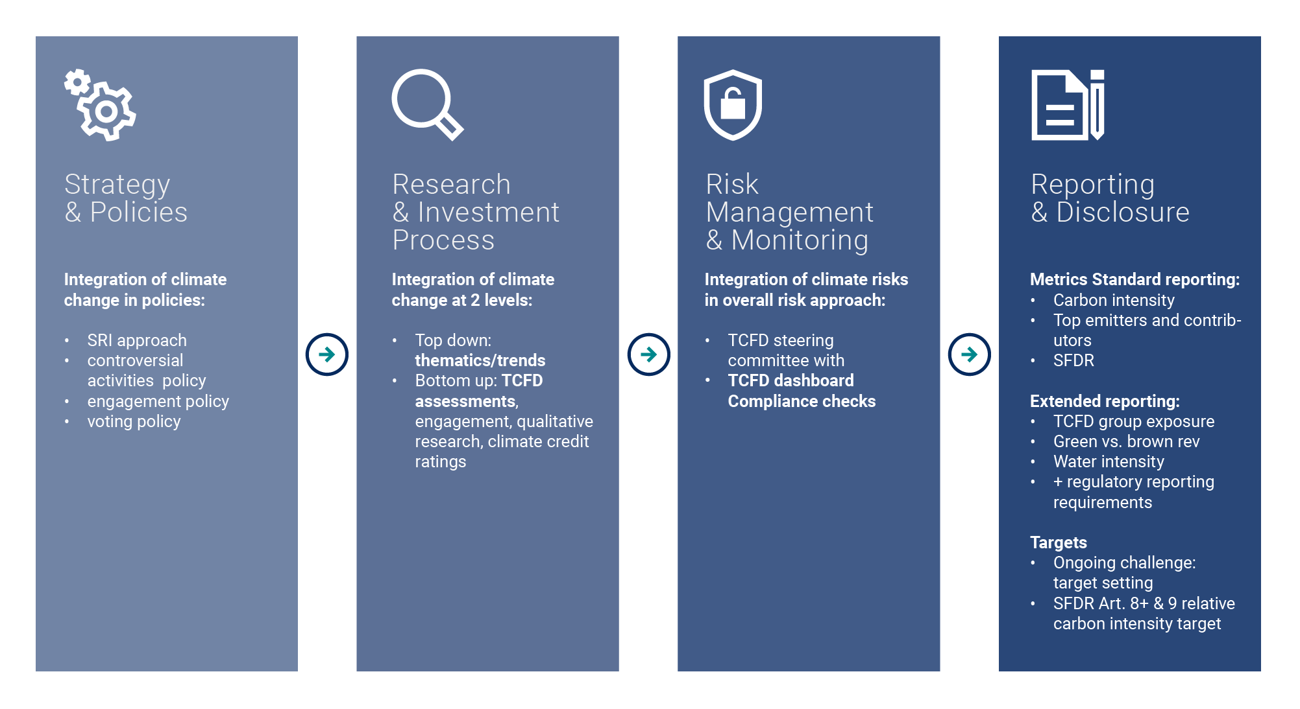

Finally, DPAM’s Net Zero commitment is reflected in a target to follow the science-based targets portfolio coverage approach for its SFDR-defined article 8, 8+ and 9 strategies. However, following discussions with one of our membership organisations on our approach to Net Zero, it was stressed that DPAM should reflect our activities, as stipulated in our TCFD report, according to GFANZ’s framework ‘Financial Institution Net-Zero Transition Plans’ due to the significant overlap and alignment with the proposed framework. To align with market practices, in the coming year, we will transition disclosures according to the GFANZ framework.
The GFANZ framework, similar to DPAM’s approach, covers financial institutions’ scope 3 financed emissions, consistent with the sector-specific net-zero alliance commitments.

Comparing GFANZ’s FI Net Zero Transition Plan framework and DPAM’s TCFD approach

GFANZ financial institutions net-zero transition plan framework
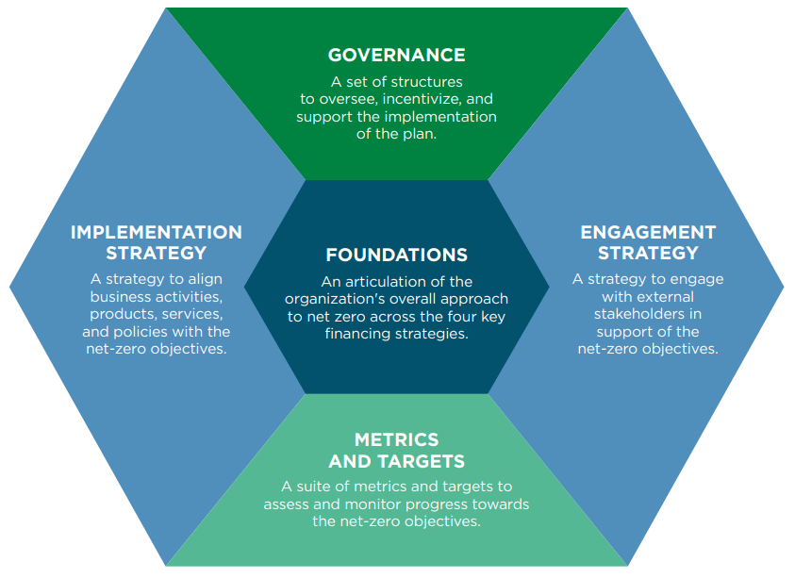
DPAM net-zero transition plan implementation
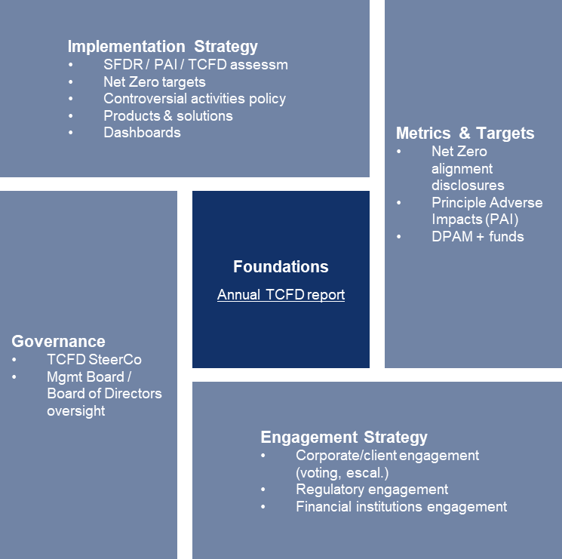

Source: GFANZ; DPAM

A more detailed overview of alignment with the GFANZ framework, with references to the corresponding section in the 2023 report, is provided further in the report (see section ‘3. FROM TCFD TO GFANZ’).
- Preamble

- DPAM, an experienced sustainable investor
DPAM has been developing credible, responsible investment solutions for several years, based on over 20 years of expertise.
As at December 2023, DPAM is managing approximately EUR 47.1 billion (gross AuM). All our investment strategies integrate environmental, social and governance criteria in the investment decision making process. The integration of sustainability in our investment decisions starts from a single-minded conviction: to foster a sustainable long-term economy. The sustainable investment strategies, totalling approximately 57% of all AUM (dd. December 2023), are built upon a specific, threefold commitment, to:
- defend basic and fundamental rights, i.e. Human Rights, Labour Rights, fight against corruption and protect the environment;
- express an opinion on controversial activities, i.e. no financing of the usual suspects, define a clear controversial activity policy, engage on controversial issues and avoid controversies that may affect reputation, long term growth and investments.
- be a responsible stakeholder and promote transparency, i.e. find sustainable solutions to ESG challenges, and engage with companies to promote best practice and improvements.

- Climate change risks continue to increase within a challenging macro-economic and (geo)political environment
Over the past decade, the impact of climate change on society has become significantly more severe. Unfortunately, 2023 was yet again marked by record droughts, heatwaves, forest fires and floods. This followed challenging years in the aftermath of covid 19 and the war in Ukraine, which triggered global inflationary shocks, food worries, energy shortages and deglobalisation. In addition, in 2023, emissions increased by an additional 1.1 percent (see figure below). The increase can be mainly attributed to the economic rebound combined with fuel switching as a result of the energy crisis. What were the consequences and what can we expect in the coming years?
- As a result of ever-increasing emissions, for the first time, global average temperature exceeded 1.5°C threshold in the second half of 2023, although we should note the short-term El Niño (a warming of the ocean surface, or above-average sea surface temperatures, in the central and eastern tropical Pacific Ocean) influenced the warming trajectory.
- Global warming continues to harm society. Over the past 20 years, the damage caused by climate change through 185 of the most significant extreme weather events has cost an estimated USD 16 million per hour, according to a 2023 study published in the journal Nature Communications.
- The IPCC forecast global average temperature to reach 1.5°C before 2035, causing significant impacts, including increasingly extreme weather conditions.
- To limit global warming to below 2°C, a substantial amount of funding is required with estimates ranging up to USD 4.5 trillion, annually, by 2030.

Respondents to the World Economic Forum’s Global Risk Perception Survey shared the view that this was urgent (see Global Risks Report 2024) as:
- Extreme weather events rank second in estimated severity over a two year period and ranked first over a ten year period, followed by critical change to earth systems, biodiversity loss and ecosystem collapse and natural resources shortages.
- 66% of correspondents selected extreme weather as the risk most likely to present a material crisis on a global scale in 2024.
It is clear that urgent alignment of economic, climate, and security priorities is needed. So what did the most important climate event of 2023 bring?
COP28 has been perceived as historic by some, due to the progress made and the number of additional commitments. These include the objective of ‘tripling renewable energy capacity globally and doubling the global average annual rate of energy efficiency improvements by 2030’ in the final Global Stocktake decision and the fact that it is the very first time in 28 years of negotiations where it is clearly stated that we need to move away from fossil fuels in general, and not exclusively from coal, while also targeting other actions such as the phasing out of inefficient fossil fuel subsidies. Currently, 80% of the global population and 91% of global GDP are covered by Net Zero commitments. Nevertheless, the scientific community remains sceptical, as ‘transitioning away’ is clearly a weaker statement than ‘phasing out’, allowing countries to keep investing in new fossil fuel projects.
Except for the development of renewable energy capacity, the announced commitment would represent an average yearly increase of 17% — which corresponds to the current annual increase observed since 2016 (Carbon Brief, 2023). This can be either interpreted as a lack of ambition or as a realisation by governments that renewable energy can indeed be scaled up by almost 20% per year. Doubling the annual rate of energy efficiency improvement by 2030 – currently at 2% – would represent an annual improvement rate of 4% by the end of the decade (Carbon Brief, 2023).
The final Global Stocktake decision highlighting the rapid transition away from fossil fuels, the tripling of renewable energy and the doubling of energy efficiency – as decided upon at COP28 are core components of the IEA’s 1.5°C compatible scenario (IEA, 2023). These keep the 1.5 C ambition alive. Limiting global warming to 1.5°C with no or limited overshoot requires a 43% GHG reduction by 2030, and a 60% reduction by 2035 relative to the 2019 level. First movers, like the EU have shown actual emissions reduction progress (see table below).

Global CO2 emissions MtCO2 per day to December 2023
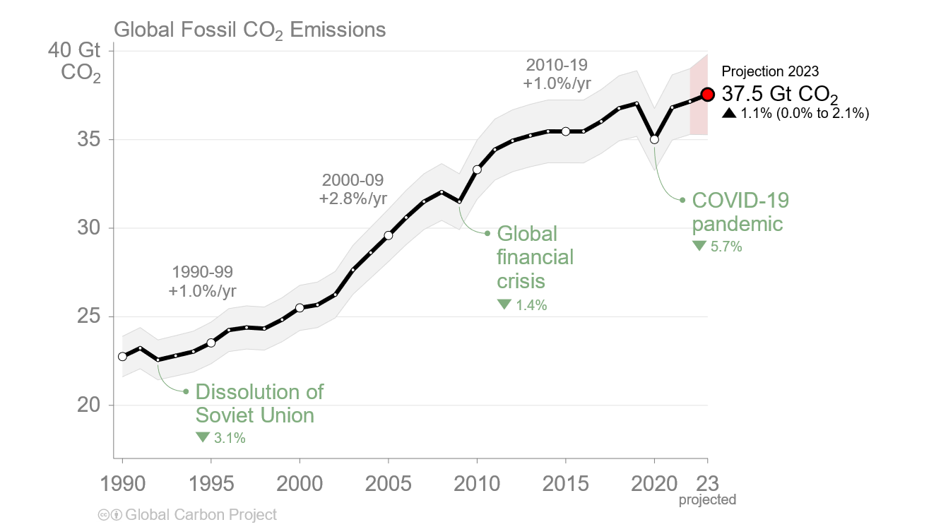
Source: Global Carbon Project (2023)

Fossil CO2 emissions in 2022 and 2023 by region

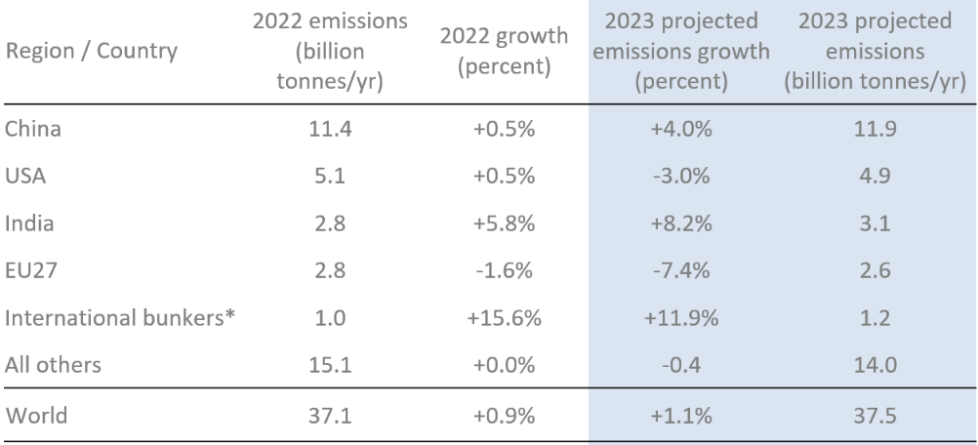
* Emissions from use of international aviation and maritime shipping bunker fuels are not usually included in national totals.
Source: Friedlingstein et al 2023; Global Carbon Project 2023

However, the next two years, will be critical to put the Paris Agreement to work and to ensure all parties ramp up their efforts. Climate financing-related events to monitor over 2024-2025 are:
- Elections more than ever: Countries and regions home to nearly half of the world's population will hold elections in 2024 and 2025, from the US, the UK and the EU to Indonesia, Russia and South Africa. These elections take place as several of these countries face a backlash against climate action while protectionism, particularly in relation to energy increases. We expect the outcome to significantly impact climate-related investing, although the exact results are uncertain.
- Developments in global conflicts: Conflicts including the Russia-Ukraine war, the Israel-Palestine conflict, and the US-China trade war will all have implications for climate-related supply chains, inflation, global commodities and energy prices.
- Developments at EU Level: Various developments at EU level will impact this goal. In particular the European Commission have recently announced their proposal for a commitment to reduce net greenhouse gas emissions by 90% from 1990 levels by 2040, although approval will depend on the outcome of the Parliamentary elections in June. The Net Zero Industry Act is progressing as a provisional agreement on the final form of the Act has been reached between the Parliament and the Council and formal adoption is expected. The proposed act envisages major benefits/improvements for the solar manufacturing industry including: a reduction in permit delivery for large renewables projects, promotion of ‘Net Zero Acceleration Valleys’ and application of pre-qualification and award criteria which are not price related. Funding decisions by the EU Innovation Fund, allowing access to EUR 4.8 billion for the deployment of net zero technologies (including carbon capture and storage and hydrogen) will have important impacts as well as the deployment of 166 cross-border energy projects, to fuel the European Green Deal. It is worth watching how well the EU tackles the alignment of grid infrastructure investments with renewables deployment to avoid bottlenecks and how regions and corporates diversify supply chains. Lastly, several revisions of the EU Emissions Trading System in combination with market effects like the ramp-up of renewables resulted in a sharp decline of the allowance price, with prices dropping to EUR55/ton in February 2024, reaching a 23-month low. Will one of the key pillars of the EU’s climate ambitions hold ground in coming years, to drive decarbonisation efforts?
- Evolutions in Asia: These include an expected emissions peak in China, Japan emerging as the first issuer of sovereign transition bonds, and changes in India’s coal versus renewables expansion rate.
- US Developments: The US situation is very uncertain due to the following: the presidential election; the progression of implementation of the US Inflation Reduction Act and the long-awaited disclosure rules from the Securities and Exchange Commission, expected around mid-2024.
- US China Climate Talks: It is not clear whether there will there be further cooperation or competition between the greenhouse gas giants, after the departures of climate diplomats John Kerry and Xie Zhenhua, who paved the way for landmark agreements.
- The aftermath of El Nino as well as other extreme climate events: This will impact citizens, corporates, and sovereigns and potentially fuel inflation. For corporate actors, physical events might result in operational impacts or supply chain disruptions, whereas for the latter, sovereign credit risk might increase. As a result, central banks awareness of physical risks, the ability to access rapid financing facilities and the option to take on extra debt and/or the multilateral availability of financing alternatives are elements to monitor.
- Mandatory Corporate Climate Transition Plan disclosure requirements: Further developments across regions, including the EU, US, China, and the UK, will impact corporates directly, but also indirectly through demand and supply dynamics.
- Climate-related scrutiny of financial industry regulations: Climate-stress testing and capital requirements of the European Central Bank, the Bank of England and the Federal Reserve as well as the European Central Bank’s greening programme and insurance supervision will be important.
- Price dynamics linked to renewables and EV competition alongside technological developments: Look out for advances in carbon removal, nuclear power and hydrogen as well as climate tech venture capital growth and developments in artificial intelligence to decarbonise the economy. Note that the European Central Bank also said it is ready to consider further adjustments to its monetary-policy approach to support the transition to a green economy.
Overall due to (geo)political and political uncertainty and protectionism and its effect on the (macro) economy, several research entities expect 2024 and 2025 to be bumpy years for financial institutions, resulting in head and tailwinds, especially for those pursuing climate financing targets. The effect of these multiple interrelated events will significantly impact the success of COP29 and COP30 and our ability to meet the 1.5°C warming objective of the Paris Agreement with associated investment implications.
In line with our threefold commitment, we believe that the climate-related challenges we are facing today need to be properly taken into account in our investment decision making process, since they can pose significant risks to our investments and society at large.

- Integrating climate change factors: DPAM’s fiduciary duty and ambition for continuous improvement
As a long-term responsible investor, DPAM acknowledges its unique position to contribute to the fight against climate change and support the Paris Agreement on climate change. Hence, in November 2018, DPAM welcomed the recommendations of the Task force on Climate-related Financial Disclosure (TCFD), an initiative led by the Financial Stability Board, to promote more informed investment, credit, and insurance underwriting decisions as we strongly believe it will enhance our investment processes and decisions. Furthermore in 2022, as part of our fiduciary duty, DPAM formally committed to the Net Zero Asset Managers initiative (NZAMi), an international group of asset managers committed to supporting the goal of net zero greenhouse gas emissions by 2050 or sooner, in line with global efforts to limit warming to 1.5 degrees celsius; and to supporting investing aligned with net zero emissions by 2050 or sooner. More information on the initiative can be found further down the report, in the section VI. Metrics and Targets.
By integrating climate change risks and opportunities in our investment decision process, we try to assess the impact of climate change on our investments and at the same time assess the impact of our investments on climate change. Supporting the TCFD recommendations and improving disclosure in essence means contributing to the fight against climate change and at the same time providing our investors with adapted investment solutions and relevant information concerning climate risks and opportunities. In other words, we truly believe it is an inherent part of our fiduciary duty to integrate the TCFD recommendations.
However, as stated by the Principles for Responsible Investment, the integration of the TCFD recommendations into investment decision making is a complex process, a process of ‘learning by doing’. At DPAM, we see implementation as a step-by-step approach, which is driven by our ambition to continuously improve. That is why, during this journey, it is our desire to be as transparent as possible and highlight, with humility, the steps we have already taken, while at the same time expressing our ambitions and acknowledging areas for future improvement.
In this document, we describe our approach to managing climate-related risk (i.e. identification, integration and mitigation) and seizing opportunities (i.e. supporting the transition and financing solutions and innovations). We provide an overview of actions taken and highlight some areas in which we evolved in 2023.
We truly hope you will find this document enriching and insightful.
Enjoy the read!
The TCFD Steering Committee
Peter De Coensel  CEO & Chairman of the TCFD Steering Committee | Ophélie Mortier  Chief Sustainable Investment Officer | Gerrit Dubois  Responsible Investment Specialist | Jeroen Sioncke  Head of Risk Management | Koen Bosquet  Portfolio Manager Fundamental Equity
Philippe Denef  CIO Quantitative Equity & Asymmetric Management | Pierre Reymond  Risk Manager | Michael Oblin  Head of Credit Research | Ivo Dierick  Senior buy-side analyst - financials | Ronald Van Steenweghen  Portfolio Manager Fixed Income
Olivier Van Haute
Head of Global Balanced Fund Management



- Implementing the TCFD recommendations: Intro

- Objective of the TCFD recommendations
The TCFD recommendations were published with the aim of enhancing climate-related financial disclosure, by providing a framework for disclosing the integration of climate-related risks and opportunities in investment decision making (see Annex I). The framework is built on four pillars:
- Governance: focuses on board oversight and the role of management.
- Strategy: focuses on the process for risk identification, its link with asset allocation and performance assessment and the use of scenario analysis to assess the resilience of an investment strategy.
- Risk Management: includes risk materiality assessment, data identification and use, risk measurement and prioritisation.
- Metrics and targets: focuses on the use of metrics to understand and manage risks and opportunities.
The above-mentioned pillars have gradually been integrated in both mandatory and voluntary reporting frameworks worldwide, targeting both financials and non-financials. A glimpse of these frameworks includes the EU’s CSRD (mandatory – financials and non-financials), California’s CA SB 253 and CA SB 261 (mandatory – non-financials), or GFANZ’s NZAM standard (voluntary - financials).
So how are climate-related risks and opportunities managed and integrated by DPAM and does our approach comply with the above-mentioned frameworks?

- DPAM’s approach
As mentioned by the Principles for Responsible Investment (PRI), the implementation of the TCFD principles is a multi-year process. DPAM’s TCFD process started in 2019 – this serves as our baseline year, year one. During 2023, we enhanced our approach in line with the recommendations and are gradually moving towards the targets defined in phase three, the most ambitious level.

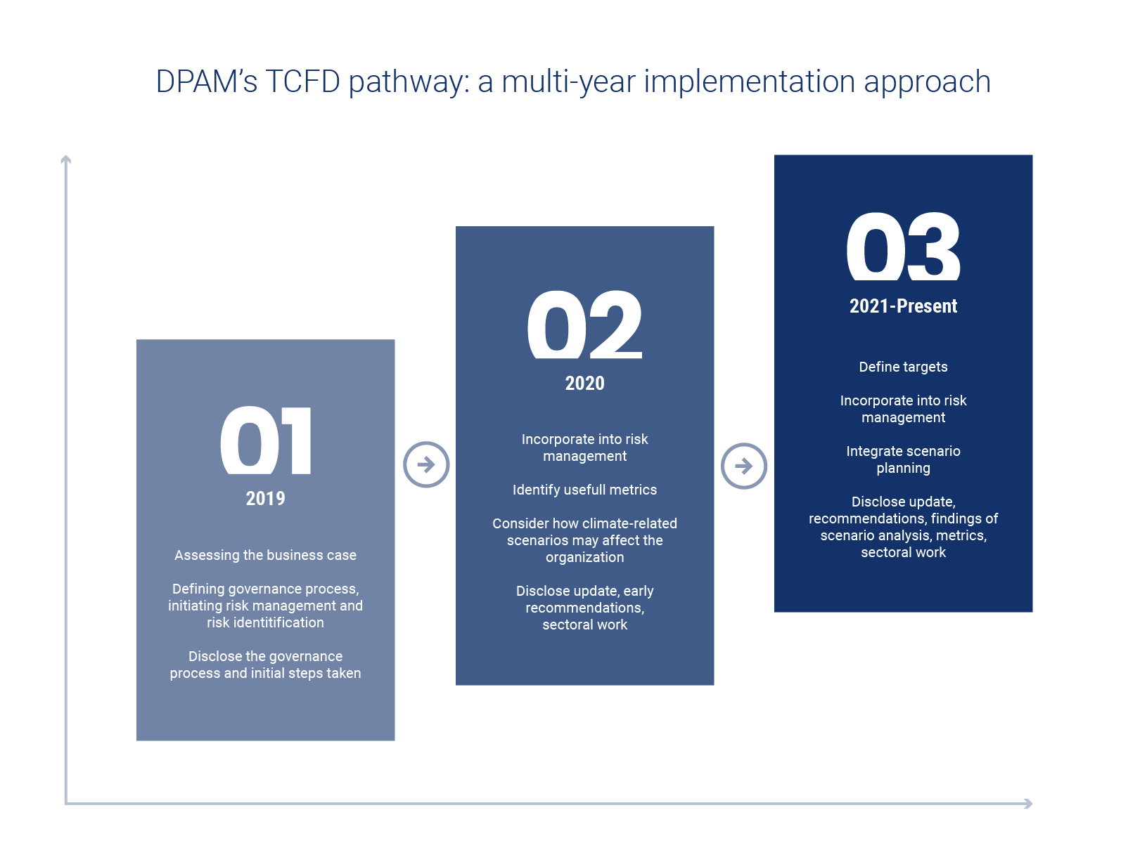
Source: PRI

In the following sections, and in a similar way to our previous report, DPAM’s implementation approach for the year 2023 is explained in accordance with the four pillars of the Task Force on Climate-related Financial Disclosures and GFANZ’s NZAM framework. The responsibilities, approaches, procedures, etc. established in previous years (2019-2022) are listed in this 2023 report where they are still applicable. Phase III turned out to be more complex, especially the element scenario analysis and planning. As a result, throughout 2023 we continued to focus on the latter, this will continue throughout 2024.
- From TCFD to GFANZ
DPAM’s Net Zero commitment is reflected in a target following the science-based targets portfolio coverage approach for its SFDR-defined article 8, 8+ and 9 strategies. However, following discussions with one of the organisations we are a member of, regarding our approach to Net Zero, it was stressed that we should reflect our activities, as stipulated in our TCFD report, according to GFANZ’s framework ‘Financial Institution Net-zero Transition Plans’ due to the significant overlap and alignment with the proposed framework. To align with market practices, in the coming year, we will transition our disclosures according to the GFANZ framework.
The GFANZ framework, similar to DPAM’s approach, covers financial institutions’ scope 3 financed emissions, consistent with the sector-specific net-zero alliance commitments.
Comparing GFANZ’s FI Net Zero Transition Plan framework and DPAM’s TCFD approach
GFANZ financial institutions net-zero transition plan framework
DPAM net-zero transition plan implementation
Source: GFANZ; DPAM

A more detailed overview of alignment with the GFANZ framework, with references to the corresponding section in the 2023 report, is provided below:

Foundations | Governance | Implementation strategy | Engagement strategy | Metrics & targets
Objectives and priorities:  See NZAM commitment. | Roles, responsibilities, and remuneration  See ‘Governance’ section. | Products and services  - ‘Targets: SFDR, Controversial Activities, and the road to net zero’  - ‘Climate solution: Facilitating the green transition with a climate-focused investment strategy’  - ‘Climate solution: Continuing our efforts in other asset classes’  - ‘Engagement linked to climate change‘ | Engagement with clients and portfolio companies  ‘Engagement linked to climate change‘ (Engagement priorities, Collaborative engagement, Active ownership, Knowledge sharing) | Metrics and targets  See ‘Metrics and Targets’ section.
 | Skills and culture  See ‘Governance’ section. | Activities and decision-making  - ‘TCFD aligned climate risk assessment approach – DPAM proprietary assessment sheet’  - ‘Managing climate-related risks at company level: enhancing our TCFD dashboard’  - ‘Scenario analysis and integrated accounting’  - ‘Engagement linked to climate change‘ | Engagement with industry  ‘Engagement linked to climate change‘ (Collaborative engagement, Active ownership, Knowledge sharing)
 |  | Policies and conditions  ‘DPAM level criteria: strengthening portfolio construction criteria’ | Engagement with government and public sector  ‘Engagement linked to climate change‘ (Collaborative engagement, Active ownership, Knowledge sharing)

- Governance

All DPAM’s investment activities are steered by the Management Board. It is no different for our climate change strategy and risk management process. As such, the Management Board retains oversight of the progress we make in terms of integrating the TCFD recommendations.
The Responsible Investment Steering Group (RISG) oversees the implementation of DPAM’s mission statement with regard to responsible investment and consists of 15 investment professionals, including our CEO and representatives from different teams (research, portfolio management, responsible investment competence center, RfP, strategy and legal). The RISG is both the pioneer and the guardian of the coherence, consistency and credibility of DPAM’s investment processes in light of our strategic commitment towards responsible investing and as a result is also actively involved in the implementation process of the TCFD recommendations. The RISG gathers on a monthly basis and directly reports to the Management Board.
Furthermore, the Responsible Investment Competence Center (RICC) manages our sustainable activities on a daily basis. The RI Competence Center, headed by our Chief Sustainable Investment Officer Ophélie Mortier and supported by five additional full-time ESG specialists, is in charge of the coordination of all initiatives, methodologies and projects related to ESG. Our CSIO reports directly to DPAM’s Management Board and to the CEO of DPAM.
To steer the TCFD implementation process, a committee of investment professionals was set up. The TCFD Steering Committee is chaired by our CEO and consists of several Board and RISG members (including the CIOs for equities and fixed income) in addition to the heads of research for equities and fixed income. To align activities within the group (Bank Degroof Petercam) some colleagues from other branches (group, private banking, corporate communication) join the committee meeting. A detailed description of the roles and responsibilities of the committee, validated by DPAM’s Management Board, can be found in Annex II.
In addition to the above actions and responsibilities of the TCFD Steering Committee, the RICC remains the guide in identifying new tools, techniques and sources to facilitate the implementation process, by providing support to portfolio managers and analysts during the integration of climate-related metrics into their assessments and by steering different types of climate-related engagement activities. To track progress on the implementation of the TCFD recommendations, the RICC developed and manages a monitoring tool.
Integrating climate-related risks and opportunities in investment decision making is everyone’s responsibility at DPAM, from portfolio managers and analysts to our risk management team and the Management Board. Indeed, due to the complexity of identifying and assessing climate-related risks and opportunities, knowledge sharing and interaction are crucial to reaching the ultimate goal of quantifying climate-related risks and opportunities. As a result, over the course of 2023, we continued our training activities, both internally and externally. A bespoke training module was set up for all investment professionals, from portfolio managers and analysts, to sales and marketing on several topics, which integrated climate elements such as TCFD risk assessments, engagement and the EU Taxonomy regulation. The trainings, which were accompanied by a formal test, included the applied frameworks, our approach, actions taken and next steps. Interestingly, those trainings also provide insights on the approach and views of our clients. By sharing specific client requests linked to climate change, and discussing our approach, we strongly believe our sales teams are better prepared to handle similar requests in the future, with a critical mindset and background information on DPAM’s approach.
Furthermore, linked to our strategy and risk management approach, several SRI policies were revised in 2023 to take into account climate-related risks and opportunities (for example, the Controversial Activities Policy, the Engagement Policy and the Voting Policy). More information can be found in the next section.
To conclude, we continued the process of involving our Board of Directors and Risk Committee in the assessment of ESG risks at DPAM level. On the environmental side, climate change has been prioritised, following the approach defined by the TCFD Steering Committee (see section ‘1. Managing climate-related risks at company level: enhancing our TCFD dashboard’).
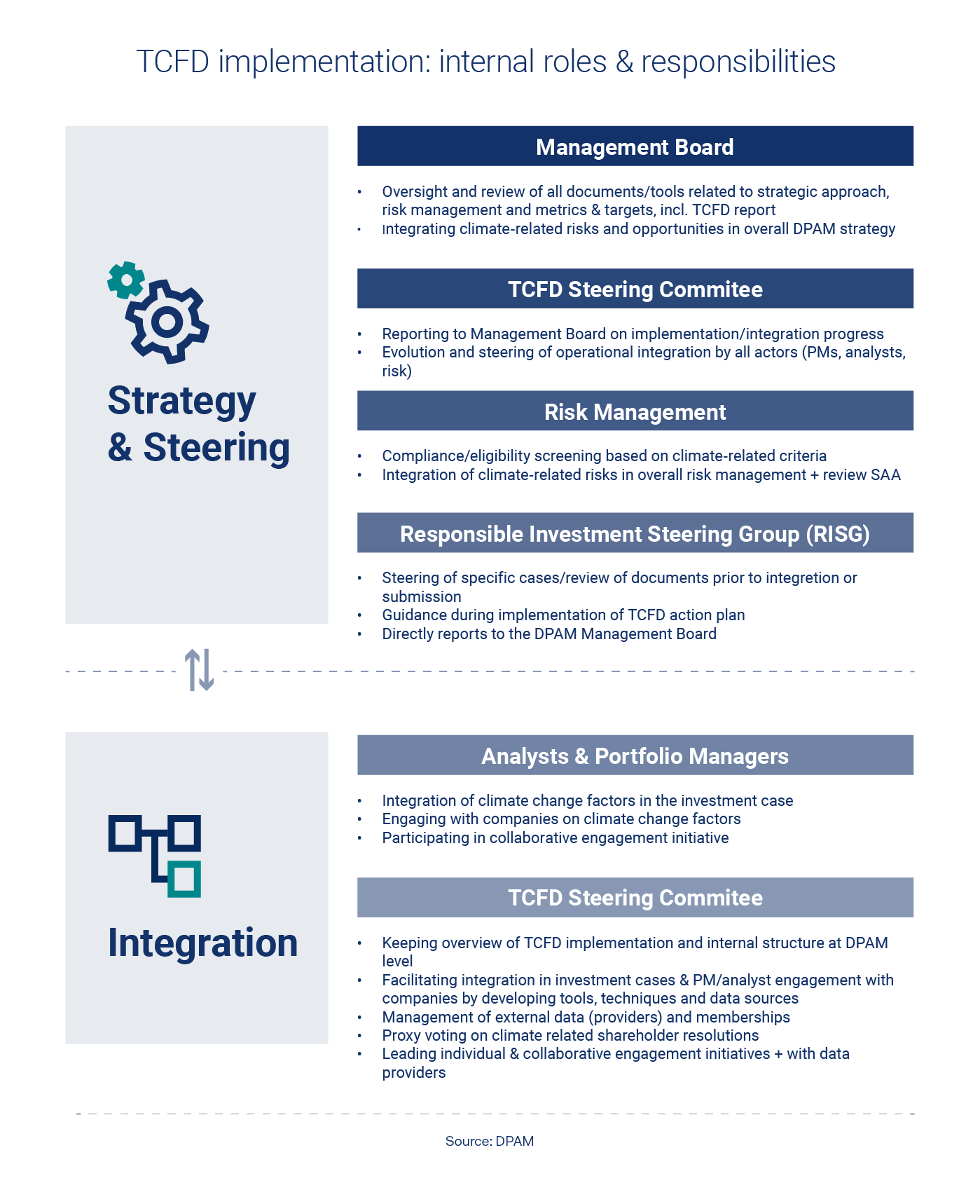
- Strategy & risk management

- Linking climate change and DPAM’s investment activities
As an Asset Manager, DPAM manages investment strategies (i.e. funds and mandates). The optimal assessment of risks and expected returns is core to our business. Apart from the direct climate impact on our investees (physical and transition risks), climate change also has a more direct impact on our investment activities, for instance via specific regulation for asset managers or requests coming from our (institutional) clients (please see below.

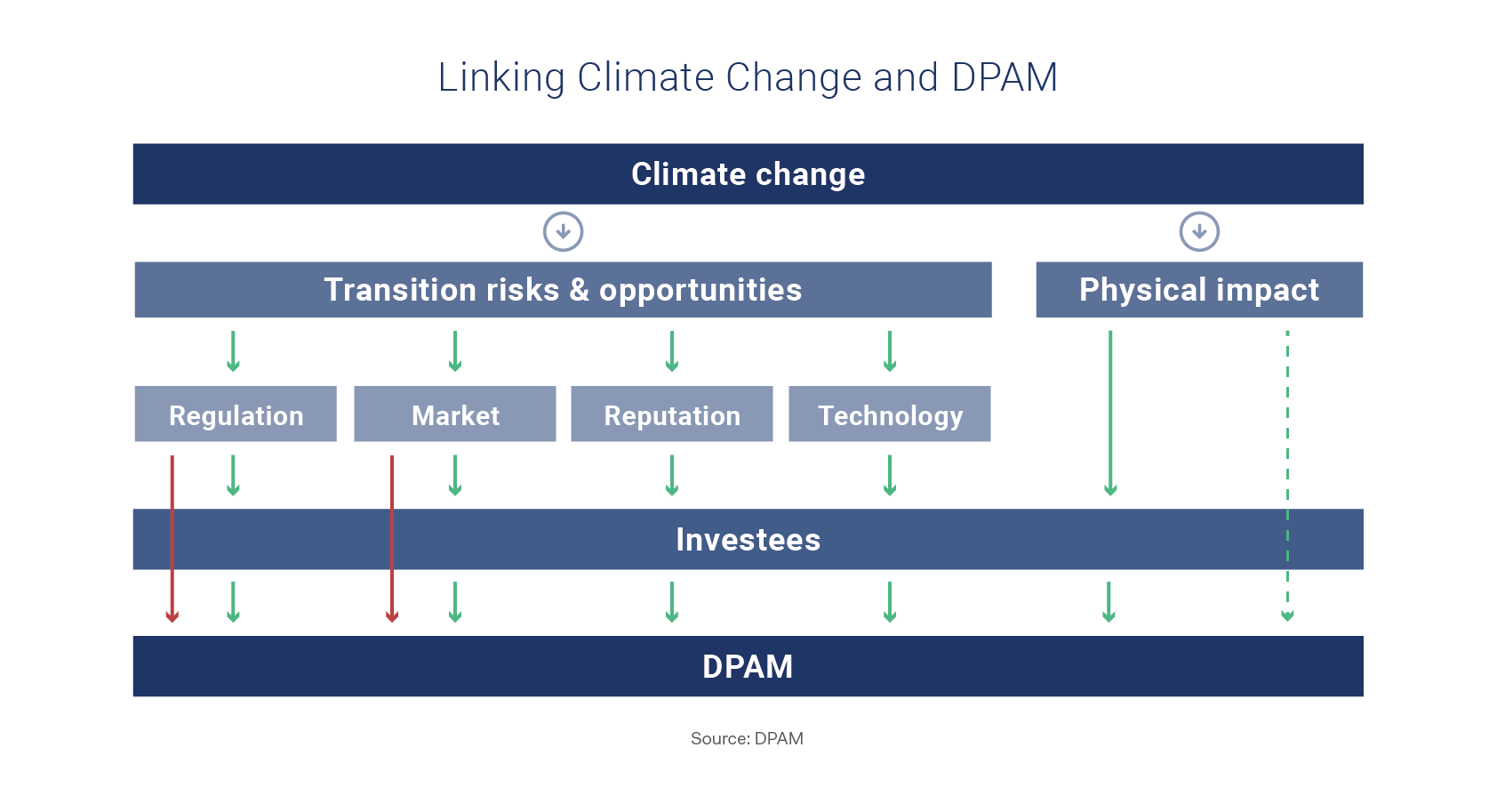
Source: DPAM

As mentioned earlier in this report, 2023 was yet another challenging year with respect to climate change (please see section 1). To mitigate climate risks and contribute to the transition, DPAM continued with the implementation of the TCFD recommendations, begun in 2019. In 2023 we enhanced our approach and integrated climate-related risks and opportunities to a greater extent in our investment decision making processes. On the one hand, we focused on climate alignment from a values perspective (see also Engagement for Values and Convictions). On the other, we focused on transition alignment from a value perspective. This includes assessing the impact of (corporate) targets and target achievement on shareholder value creation. This could be complemented by engagement. The figure below shows the link between climate-related risk management and net zero transition planning.
The relationship between risk and transition planning

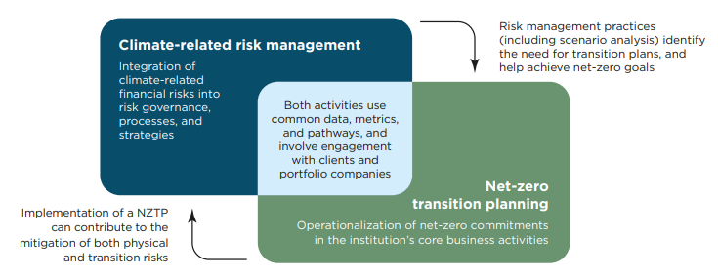

Source: GFANZ

In the following sections, we will describe DPAM’s approach to identify, assess and mitigate the impact of climate change on our investment activities through our investees, as well as the more direct impact of climate change on our investment activities.


1.1. Climate-related risk identification and risk management

- TCFD aligned climate risk assessment approach –initial assessment of the risk exposure of our investees
From a strategic and risk management perspective, our RICC performed an initial sector exposure assessment for the most material climate-related risks using the TCFD’s framework for categorising climate-related risks and opportunities (see Annex III). The assessment, which was based on reports and data coming from external experts and data providers, focused on the risk exposure of our investees.
Based on the assessment and with the input of several internal and external sources, including the recommendations of the TCFD and data provided by organisations such as CDP, the RICC further assessed potential climate-related risks and opportunities and associated data needs, including the identification of KPIs or metrics. The exercise serves as input for the next phase of the process: the climate risk assessment of our investees via DPAM’s proprietary, standardised approach.

- TCFD aligned climate risk assessment approach – DPAM proprietary assessment sheet
The standard, industry-specific assessment template has been evolved to a more detailed template which includes company-specific information. To recap, the initial template was developed in close collaboration with our buy-side analysts and portfolio managers. The template is based on the four pillars of the TCFD (see Annex I) and consists of several company-specific, customised fields (including material risks and opportunities), which allow us to assess the strategic positioning of a company with respect to climate change and the transition towards a low carbon economy. The template requires input from multiple sources, including our external ESG/carbon data providers (i.e. Sustainalytics and Trucost) as well companies, NGOs, academic research entities and our own internal assessments.
The template has been revised to ensure several data points and metrics are automatically populated, to allow for a more qualitative review and assessment, beyond data collection. For all TCFD sectors, we defined material risks, although in the new template, we rely on material risks directly reported by our investees to CDP. Starting from the identified risks, which includes an exposure assessment in addition to quantification of costs and mitigation measures, an in-house outlook on the risk is prepared. We believe it strengthens the approach as our analysis is based on company-reported information, combined with external information. Furthermore, to identify and quantify opportunities related to the climate transition, the template has a dedicated section focusing on opportunities, which also comprises elements linked to the company’s strategic positioning (M&A activity, development of new products and services, etc.).

The relevance of DPAM’s TCFD assessment approach
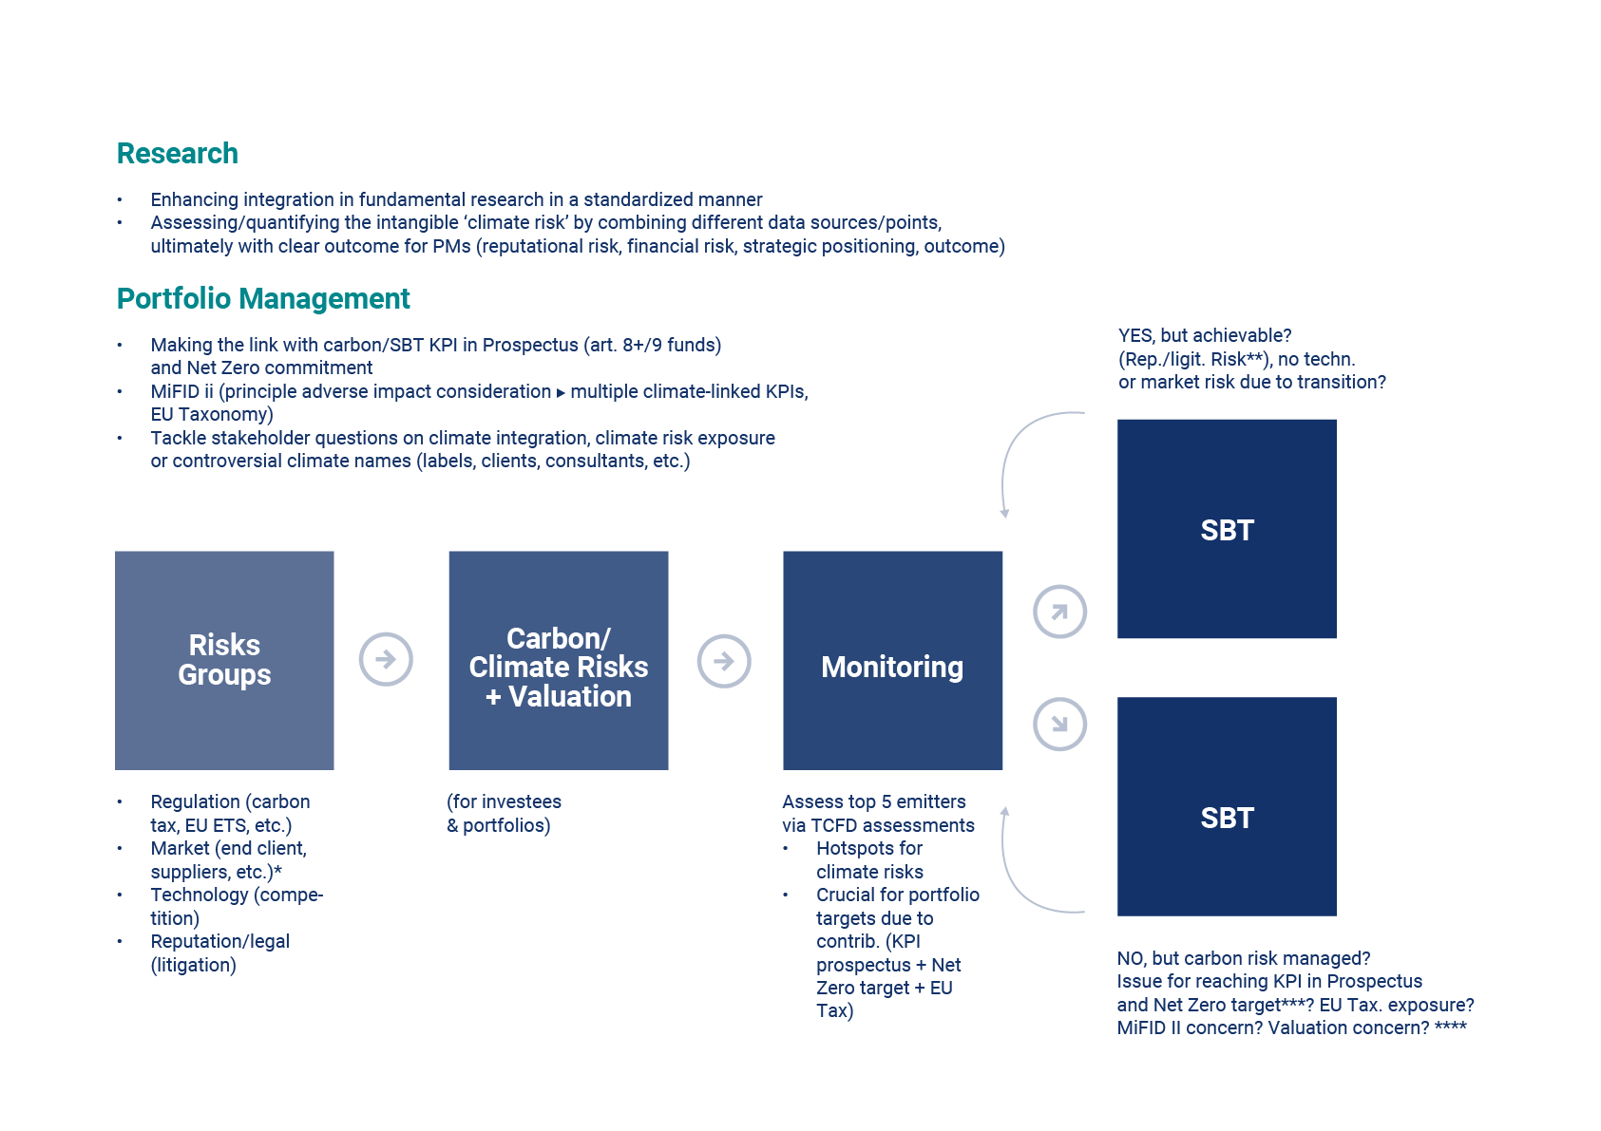
Source: DPAM

Due to the revision of the template and as part of our learning process, we re-initiated our training program in 2023. All portfolio managers and analysts received specific training, provided by the RICC, on the use of the assessment template, its indicators/metrics and the available data files and sources. New trainings have already been provided in early 2024 and these will be repeated annually.



Case study: increased conviction due to engagement, but continued monitoring required
Recent years were characterized by a rise in SBTi commitments and validations. However, M&A activities or spinoffs and separations of businesses have, unsurprisingly, impacted ESG commitments and targets, including climate targets. As a result, following the announcement of a separation of businesses at one of our investee companies and the difficulty of assessing the next steps in terms of climate risk management and the ambition of the investee (identified during the TCFD or climate-risk assessment), DPAM decided to join a collaborative engagement initiative (NZEi) to explore the implications of this split for its SBTi commitments, which form the basis for assessing whether a company’s strategy aligns with a low-carbon economy.
Together with other investors, this chemicals company was approached via a formal letter which stated our expectations for credible climate transition planning. This was followed by a virtual meeting with the company, focusing on the implications of the split for the commitments of the resulting entities. The company confirmed one of the two businesses, the low-carbon part, will inherit the target, while the company will explore the feasibility and credibility of target setting for the other, carbon-intensive entity. Some of the complexities were raised and elaborated on.
Following a debrief between investors, it was decided to reach out to the company in Q1 of 2024 to push further for more disclosures in its Annual Report 2023 and 2024 on the status, potential hurdles and timeline for a formal commitment. Further engagement will proceed on the alignment of strategy and business operations with the target (see Corporate Transition Plan disclosures).
- TCFD aligned climate risk assessment approach – What has changed during 2023?
Following the initial assessment cycles (2020-2021-2022), some revisions were implemented by the TCFD Steering Committee, at the end of 2022, to improve the implementation process. Associated insights and follow-up provided for the 2023 cycle included:
- Formal review of the assessments between analyst and PM to be enhanced by offering an extended timeframe, in addition to extended outcome options (combination of options, such as informal engagement combined with proxy voting recommendations) and support guidance documents (including key questions to tackle during the review). Based on that review, a decision is taken on the next steps (for example, increased conviction, (in)formal engagement, proxy voting, exposure changes, divestment);
- Template adjustments including regulatory compliance information. As a result of different evolutions on the regulatory front, the templates were adjusted to consider relevant fields focusing on, for example, compliance with the (preliminary) EU Taxonomy regulation and Transition Plan Disclosure recommendations and requirements. In terms of setup, more focus was put on analyst sentiment and overrule of externally provided data and information. Furthermore, as discussed above, the risk section was significantly revised to include corporate-reported material risks, financial impact estimates, mitigation costs, time horizons and likelihood estimations, with an analyst sentiment and qualitative overlay option. Furthermore, an opportunities section was added to better reflect and assess the strategic (transitioning) position of the investees that did not solely focus on risk.

Note that as mentioned in the previous report, at the end of 2022, the process was re-evaluated and some (final) changes were made to optimise the assessment. The main changes for the 2023 template included:
- Company reported data: the amount of company-reported data fields increased
- SFDR/portfolio performance: a more direct link was made with KPIs at the portfolio level, including those linked to the Principal Adverse Impact indicators, as defined by SFDR, to ensure the most carbon intensive positions are properly monitored and that portfolio managers can more easily assess and identify red flags.
- Opportunities: next to the strategic positioning versus climate-risks, a more detailed review will be made of an issuer’s positioning versus climate-related opportunities.
- Escalation approach: the final assessment outcome can be split into different actions. Analysts will have the opportunity to, among other actions, suggest escalation via proxy voting.

How is this further integrated in fundamental decision making?
Note that carbon reduction targets can be regarded with a somewhat longer time horizon, provided they are supported by enough medium-term milestones (for example, set as part of SBT targets). Like other financial and non-financial targets and data, the carbon reduction objectives of investees are analysed critically and fundamentally, for example via the TCFD aligned climate risk assessment, outlined above.
On the one hand, we need to focus on climate alignment from a values perspective (see also Engagement for Values and Convictions). On the other hand, we need to focus on transition alignment from a value perspective. This includes assessing the impact of targets and target achievement on shareholder value creation. If necessary, this involves engagement.
Much like accounting-based reporting helps us evaluate whether a company is “on track” to reach financial targets, external carbon tracking data (CDP/Trucost) helps us anticipate and evaluate environmental risks to our analysis. In doing so we aim to detect potential “misses” early.
For example, sector analysis showed that decarbonisation paths in the materials processing industry depend heavily on new technologies that are not operational/economical today. We take this into account by integrating that risk into the overall modelling (capex/opex implications and the likely readiness of technology). This has meant that, within materials, we have preferred companies with more tangible and profitable paths to emission reduction, for example those relying more heavily on more cost-efficient renewable energy sources. Following the European energy crisis in 2022 these companies were also financially less impacted.
Compiling the fundamental, bottom-up work ideally leads to a more forward-looking reduction target at portfolio level that leaves a buffer for non-linearity which is not too dependent on macro-economic fluctuations such as inflation and energy prices, etc.

- TCFD aligned climate risk assessment approach – Scope of the assessments
Climate-related risks can have an impact on individual positions, but also at the aggregated portfolio level. Hence, to assess risk exposure at portfolio level, it was agreed to conduct the proprietary TCFD assessment for the most GHG intensive positions (tCO2/ USD mn sales) of each actively managed investment strategy in order to have a representative view on the portfolio’s overall climate risk exposure. This was a deliberate choice, since for our actively managed sustainable strategies, the top 5 emitters based on scope 1, 2 and 3 emissions contribute, on average, over 50% of the portfolio’s total carbon intensity.
During the first quarter of the year, the top five emitters in terms of the carbon intensity of the portfolios are identified. Following this, the analysts and portfolio managers initiate the assessment according to the template. The analyst or portfolio manager covering the top five names has the discretion to override a corporate-identified risk or opportunity, as this remains an integral part of critical, in-house research. Furthermore, in case no material risks are reported to the CDP, the analyst or portfolio manager combines information stemming from peers’ reporting and industry trends to define the top three material climate-related risks for the investee. Furthermore alternatives sources cam be used, such as internally developed lists of material risks by sector or industry. Examples of risk identification can be found in the table below.

INDUSTRY | Material risk 1 | Material risk 2 | Material risk 3
Semiconductors | Carbon pricing (mainly F-gases) | Physical risks | Resource scarcity (minerals, water, gas (neon))
Automobiles | Carbon pricing/fines | Affordability + consumer backlash | Technology (availability + substitution)
Utilities (non-power) | Changing customer behaviour | Extreme weather | Stranded Assets

- DPAM level: strengthening portfolio construction criteria
DPAM’s climate commitment is also translated into the portfolio construction of sustainable investment strategies. All our sustainable strategies must comply with stringent investment criteria related to carbon intensive power generation (aligned with the Paris Agreement) and fossil fuel exposure.
In 2021, several revisions were made to the policy to align it with the investment criteria of the Towards Sustainability label. As such, the following stringent eligibility criteria apply for our actively managed sustainable investment strategies:
- Thermal coal: all issuers with a revenue exposure > 0% in the mining, exploration or extraction of thermal coal are excluded in addition to issuers classified under GICS 10102050 “Coal and Consumable Fuels”. Furthermore, issuers with an increase in absolute production of/capacity for are excluded, unless they set a science-based emissions reduction target, derive less than 5% of their revenues from thermal coal-related activities, have less than 10% of CapEx linked to thermal coal or have over 50% CapEx dedicated to EU Taxonomy contributing activities.
- Unconventional oil & gas: shale gas, shale oil, oil sands and arctic drilling: all issuers involved in the exploration or extraction of unconventional oil and gas or providing dedicated equipment or services, or planning for an increase in absolute production or capacity are excluded. Other issuers can be eligible only if they set a science-based emissions reduction target, derive less than 5% of their revenues from unconventional oil and gas related activities or have over 50% CapEx dedicated to EU Taxonomy contributing activities.
- Conventional oil and gas: All issuers involved in the exploration, extraction, refining and transport of oil and gas, or providing dedicated equipment or services shall be excluded except if they meet at least one of the following criteria: have a science-based emissions reduction target, derive less than 5% of their revenues from oil and gas related activities, have less than 15% of CapEx dedicated to oil and gas related activities not with the objective of increasing revenue or have over 15% CapEx dedicated to EU Taxonomy contributing activities.
- Electricity generation from fossil-fuels and non-renewable energy sources: exclusion of issuers involved in the generation of power/heat from non-renewable energy sources or providing dedicated equipment or services with a structural increase in the absolute production of or capacity for coal-based or nuclear-based energy-related products/services. An issuer is eligible if its production of/capacity for contributing activities is increasing but it meets at least one of the following criteria, the issuer has: a science-based emissions reduction target; or derives less than 5% of their revenues from oil and gas related activities; or derives more than 50% of its revenues from contributing activities; or has over 50% CapEx dedicated to EU Taxonomy contributing activities.

Note that electricity utilities with a carbon intensity lower than the annual thresholds presented by the IEA and which are not structurally increasing coal- or nuclear-based power generation capacity, are eligible (grandfathering). Furthermore, it should be noted that issuers violating the above criteria, but issuing green bonds, can be exceptionally considered eligible. In this specific case, provided the use-of-proceeds bond (by default green bond) is estimated to be contributing positively to the energy transition and/or to the mitigation of climate change risks, then the use-of-proceed bond can be eligible for investment in DPAM Sustainable strategies.
DPAM is, however, moving its focus beyond actively managed sustainable strategies. As such, the Controversial Activities Policy was upgraded in 2021 with exclusions on coal mining, coal power generation and oil and gas extraction activities for DPAM’s mainstream active and index strategies. The decision to add these exclusionary criteria to a broader AuM scope were driven by financial sustainability risk concerns. More details can be found in our Controversial Activities Policy.
A dedicated section on oil and gas exposure was added to reflect our investment philosophy and approach concerning transition strategies. As a general rule and unless otherwise stated, DPAM Transition strategies apply the same exclusions as DPAM Sustainable strategies except for conventional oil and gas and unconventional oil and gas. With regard to conventional oil and gas and unconventional oil and gas, DPAM transition strategies apply specific exclusion thresholds.
The thresholds apply to all issuers involved in the exploration or extraction of unconventional oil and gas or providing dedicated equipment or services and are as follows:
- For a given issuer, in case the share of its oil and gas production from Arctic drilling in its total production is superior to 10%, the issuer is excluded;
- For a given issuer, in case the share of its oil and gas production from unconventional oil and gas26 in its total production is superior to 10%, the issuer is excluded;
- Issuers shall have a strategy to reduce the adverse impact of their activities and to increase their contributing activities, if applicable.

All issuers involved in the exploration, extraction, refining and transport of conventional oil and gas, or providing dedicated equipment or services shall be excluded except if they meet at least one of the following three criteria:
- Have a Science Based Target initiative (SBTi) target set at well-below 2°C or 1.5°C, or have a SBTi ‘Business Ambition for 1.5°C’ commitment;
- Have less than 15% of CapEx dedicated to oil and gas-related activities and not with the objective of increasing revenue;
- Have more than 10% of CapEx dedicated to contributing activities on a consolidated basis AND engage with companies to disclose capex on an economic basis.

In addition, issuers shall have a strategy to reduce the adverse impact of their activities and to increase their contributing activities, if applicable.
Exceptions: grandfathering rule as mentioned above or refer to our Controversial Activities Policy.
By applying these investment criteria, in combination with the specific climate risk assessments, our investment professionals (for sustainable and mainstream strategies) increasingly question the financial viability of different business models within the targeted industries (by the label and the TCFD recommendations) and as a result have become even more critical when making investment decisions. Furthermore, following a Net Zero feasibility study performed in 2022, DPAM committed to the Net Zero Asset Managers initiative (NZAMi) and set portfolio-specific targets linked to both the Science Based Targets (SBT) portfolio coverage approach, by focusing on SBT target setting by investees and the temperature alignment approach, which considers the scope 1 and 2 temperature alignment of investees. In addition to the NZAM commitment at portfolio level, each sustainable portfolio (i.e. SFDR article 8+ or 9 fund) included a relative or absolute GHG-related KPI in its Prospectus. More information is provided in section VI. Metrics and Targets.

1.2. Strategic asset allocation, monitoring and scenario analysis
In this section, more details on our strategic asset allocation approach are provided in addition to insights on the development of scenario analysis at firm level:
- Managing climate-related risks at company level: enhancing our TCFD dashboard
- Other development in terms of monitoring and measurement
- Scenario analysis further explored throughout 2023
- Facilitating the green transition with a climate-focused investment strategy
- Continuing our efforts in other asset classes
- Dedicated, custom-made mandates with an eye for climate change and alignment with the Paris Aligned Benchmark regulation

- Managing climate-related risks at company level: enhancing our TCFD dashboard
Following on from our actions on climate-related risk assessment at issuer and portfolio level, the TCFD Steering Group agreed to step up our risk management approach DPAM-wide. In 2021, we launched several projects, involving different parties to ensure climate-related risk management was integrated in our strategic asset allocation and we continued to monitor the dashboard and implement further changes to improve its content.
As such, in collaboration with our Risk Management department, a TCFD dashboard was developed to track investments by TCFD industry. The dashboard is reviewed during quarterly TCFD Steering Committee meeting sand a number of checks are performed, for example assessing the exposure to certain industries with increased climate-related regulatory scrutiny.

Extract of TCFD dashboard: sector exposure sheet
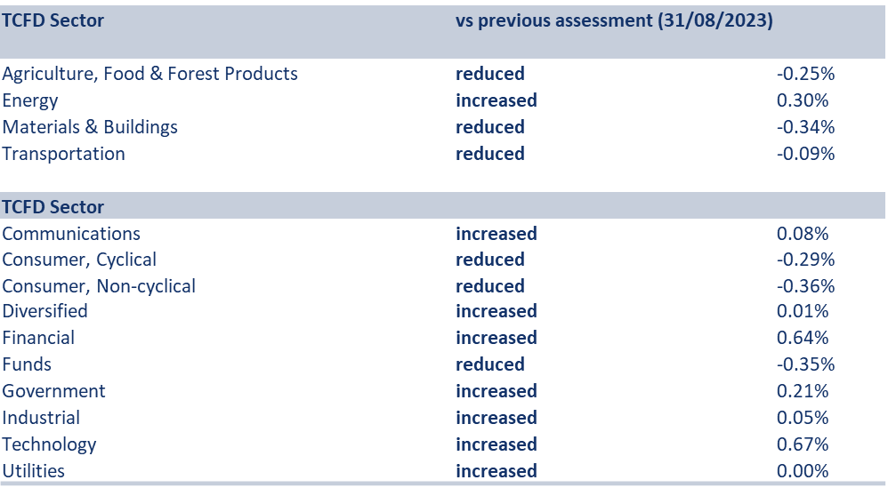
Source: DPAM
Furthermore, through the dashboard we focus on the top holdings in the most carbon intensive industries as they might pose specific investment risks if not properly managed/monitored. In recent years, several improvements/adjustments have been made to the dashboard. In addition to the exposure identification towards carbon intensive industries, scenario data for different risk indicators was added to the dashboard, an approach largely aligned with the methodologies of the European Central Bank and Federal Reserve Bank of New York factors for climate stress testing:
- Fossil fuel exposure: by focusing on the total fossil fuel exposure of DPAM investments, the objective is to monitor and manage the financial and reputational risk associated with it. Since fossil fuel exposure may go beyond the GICS energy sector classification, several indicators are retained as there is no unique indicator to assess ‘exposure’.
- Physical risks exposure: three physical climate risk scenarios are applied, based on different time horizons and temperature estimates. These are linked to seven physical risk estimates, which are aggregated at the physical asset level of an issuer to an aggregated issuer level score provided by an external data provider.
- Carbon earnings at risk: transition risks are quite broad, ranging from regulatory risks to market or technology risks and could include fossil fuels risks. As a proxy for assessing transition risks in a standardised manner, it was agreed to monitor carbon pricing risk exposure via the ‘carbon cost as % of EBITDA’ according to three scenarios, provided by an external data provider. It has however been agreed to target the more stringent scenario, due to recent market evolutions notably under the EU ETS (see further below).
Insight into the scenarios applied (assumptions and timeframes) for physical risks and carbon earnings at risk can be found in the table below:
INDUSTRY | Scenario 1 | Scenario 2 | Scenario 3
Physical risk  (provider: Trucost) | RCP*: 2.6 / <2°C in 2100  Timeframe: 2030 | RCP: 4.5 / >2°C in 2100  Timeframe: 2030 | RCP: 8.5 / >4°C  in 2100  Timeframe: 2030
Carbon earning at risk  (provider: Trucost) | Price: ca.100 USD  Metric: % of ebitda  Timeframe: 2025 | Price: ca.50 USD  Metric: % of ebitda  Timeframe: 2025 | Price: ca. 25 USD  Metric: % of ebitda  Timeframe: 2025

* RCP = Representative Concentration Pathway, a GHG concentration trajectory adopted by the IPCC, expressed in radiative forcing (W/m2) in 2100. A low RCP corresponds to low radiative forcing and hence lower temperature increase.

Based on the above indicators, warning thresholds and escalation steps are defined to ensure follow up. Our TCFD assessments at investee level start the escalation since these rely on the experience and insights of the analysts and portfolio managers. Since mitigation measures can be implemented by corporates to tackle the above-mentioned risks, the TCFD committee initiated the inclusion of mitigation-related data in the dashboard.
- Mitigation measures: to assess the mitigation commitments and capabilities of issuers in the dashboard assessment, it was agreed to add information related to science-based target setting (to assess commitments), EU Taxonomy alignment (to assess performance and/or investments) and internal TCFD assessment coverage (to assess overall risk exposure).

Extract of TCFD dashboard: sector exposure sheet
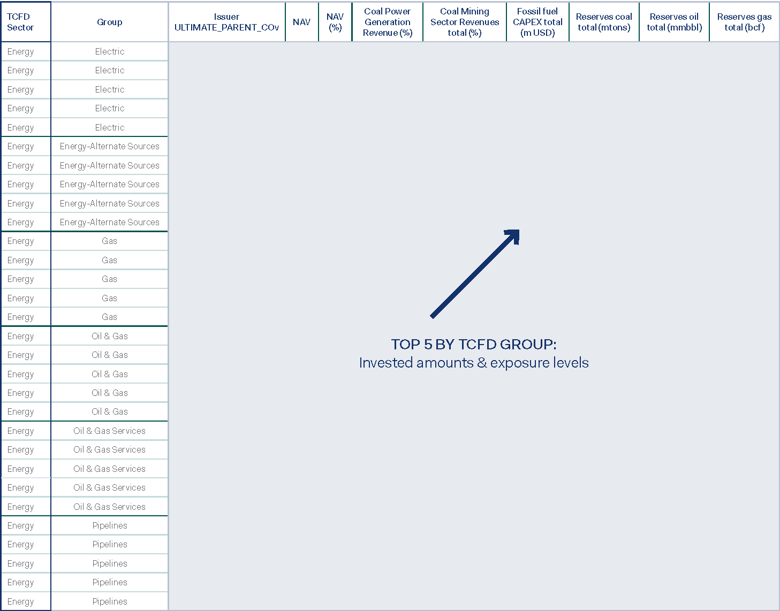
Source: DPAM

Via the dashboard above, our TCFD Steering Committee reviews asset exposure to carbon/GHG-intensive industries and further steers asset allocation decisions. As such, specific topics such as fossil fuel exposure can be assessed and aligned with our policies and convictions in addition to the traditional risk/compliance checks implemented by our RICC and Risk Management teams.
The dashboard was further extended by adding target credibility scores and GHG emissions trend information. It takes into account the target set by the investee to identify possible red flags and to allow for mitigation of financial and/or reputational risks. In addition financed emissions were added to develop insights into the weight of the issuers in DPAM’s total financed emissions, allowing for more informed monitoring and final decision making. The table below depicts this for the Materials and Buildings TCFD sector.

Rank | Group | Active Funds Exposure (%) | Index Funds Exposure (%) | CDP Rating (scope 1/2) | CDP Rating (scope 1/2/3) | SBT | Target crediblity | Target trend | TCFD assessment | SBT or TCFD | Discrepancy Target/Trend | S12 Trend | Financed emissions
1 | Aerospace/Defense | 74.67% | 25% | 1.5 | 2.0 | Approved | 73% | 3.01 | no | yes | OFF TRACK | 0.01 | 0.1%
2 | Aerospace/Defense | 34.29% | 66% | 1.5 | 2.0 | Approved | 69% | 1.5 | yes | yes | ON TRACK | -0.05 | 0.7%
3 | Aerospace/Defense | 84.19% | 16% | 1.5 | 2.0 | Approved | 77% | 1.77 | no | yes | OFF TRACK | -0.03 | 0.1%
4 | Aerospace/Defense | 0.00% | 100% | 1.5 | 3.1 | Not commited | 47% | 1.5 | no | no | ON TRACK | -0.07 | 0.0%
5 | Aerospace/Defense | 33.51% | 66% | 3.1 | 3.1 | Not commited | 47% | 3.1 | no | no | OFF TRACK | 0.03 | 0.0%
1 | Building Materials | 98.38% | 2% | 1.5 | 2.0 | Approved | 73% | 3.1 | yes | yes | OFF TRACK | 0.03 | 0.3%
2 | Building Materials | 95.78% | 4% | 3.1 | 3.1 | Committed | 35% | Not covered | no | yes | not covered | Not covered | 0.1%
3 | Building Materials | 88.22% | 12% | 1.5 | 1.7 | Approved | 92% | 1.5 | yes | yes | ON TRACK | -0.07 | 1.0%
4 | Building Materials | 85.22% | 15% | 1.5 | 1.6 | Approved | 70% | 3.1 | yes | yes | OFF TRACK | 0.04 | 0.3%
5 | Building Materials | 83.99% | 16% | 3.1 | 3.1 | Not commited | 0% | Not covered | yes | yes | not covered | Not covered | 0.0%
1 | Chemicals | 94.00% | 6% | 1.8 | 1.9 | Approved | 77% | 3.1 | yes | yes | OFF TRACK | 0.04 | 1.2%
2 | Chemicals | 72.59% | 27% | 1.8 | 2.3 | Approved | 77% | 3.1 | no | yes | OFF TRACK | 0.07 | 0.2%
3 | Chemicals | 98.62% | 1% | Not covered | Not covered | Not commited | Not covered | Not covered | no | no | not covered | Not covered | 0.2%
4 | Chemicals | 87.25% | 13% | 1.8 | 2.9 | Approved | 85% | Not covered | no | yes | not covered | Not covered | 0.0%
5 | Chemicals | 97.70% | 2% | 1.5 | 2.0 | Approved | 81% | 3.1 | yes | yes | OFF TRACK | 0.03 | 0.0%

Additionally, the top 20 positions in terms of ownership were added to the dashboard, as these issuers represent both risks (if the climate transition is not properly managed) and opportunities (for engaged dialogue or formal engagement to enhance climate risk mitigation or to seize opportunities).
To conclude, the approach, described above, is used by DPAM’s Risk Committee to assess environmental risks. A similar approach has been developed to assess governance and social risks at DPAM level.
Linked to the above-mentioned dashboard, during the quarterly TCFD Steering Committee meetings an update is provided on the market focusing on different pillars: regulation linked to climate change, financial market/industry actions, trends, relevant climate-related corporate/sector news and litigation or reputational issues and concerns. The update is passed on to investment professionals in the company, via the CIOs and the other representatives in the committee. The topics discussed during the 2023 meetings, include:
- Climate regulation evolutions 2023-2024 across Europe, Middle East and Africa, Asia-Pacific and Americas
Following national commitments to tackle global warming and its devastating consequences, regulators across the world are strengthening the rules of the game. As such, in the EU the final delegated act for the four remaining EU Taxonomy objectives was published in addition to the EU Green Deal Industrial Plan. In Canada climate risk management guidelines were finalised and in New Zealand TCFD disclosures became mandatory. Also central banks took action, with the US FED starting a pilot climate scenario analysis with six banks and the European Central Bank (ECB) published its economy-wide climate stress test results. Furthermore, the EC asked the European Banking Authority, the European Securities and Marketing Agency, the European Insurance and Occupational Pensions Authority in cooperation with the ECB and European Systemic Risk Board to test the resilience of the financial sector during the transition towards the EC’s 2030 climate targets, while the US Treasury released Principles for Net Zero Financing and Investment. Geopolitical evolutions also shaped the energy transition in 2023 and the outlook for coming years. These regulatory and financial market evolutions are discussed during every committee meeting and can result in in additional monitoring tools to anticipate related investment risks and opportunities and to align with best practice.
- Scrutiny over collaborative engagement initiatives
The (US led) ESG-backlash reached new heights as several investors refrained from their involvement in collaborative engagement initiatives such as CA100+ or the Net Zero Asset Managers initiative. Furthermore, greenwashing regulation and scrutiny gained traction, resulting in sanctions and negative media/regulatory attention. As a result, the committee assessed the status of its commitments and the possible implications. It did this by consulting investor coalitions, exploring additional reporting (according to internationally accepted frameworks), setting up additional monitoring tools (for example, on financed emissions) and assessing the credibility and viability of gaining external validation of the commitments made, among others.
Note that in terms of proxy voting, DPAM fosters collaborative dialogue with other shareholders and is open to collective proposals, but only to such an extent that dialogue and cooperation with other shareholders remains compliant with applicable law and regulation and is not considered as “acting in concert” within the meaning of the EU Transparency Directive and the Takeover Bids Directive. To demonstrate its commitment towards long-term sustainable financing, DPAM has become a signatory to various organisations that share its aim to advocate financially responsible investment. Furthermore, DPAM’s membership in dynamic international collaborative initiatives allows it to gain better insights into the challenges and opportunities that responsible investment entails.
- Nuclear power: investments, plans and regulation
In 2023, several developments took place related to nuclear power, including the announcement of a plan in the UK Spring Budget 2023, the EU’s extended Delegated Act covering nuclear under the EU Taxonomy, or the ‘Declaration to Triple Nuclear Energy Capacity by 2050’ announced at COP28. To ensure DPAM remains well positioned from an investment viewpoint, this triggered the need to revise client and broader stakeholder perceptions on investing in nuclear power. As a result, a consultation took place to assess the views of our European client base. The output and arguments raised by clients to refrain from or push for exposure to investments in nuclear power was also used in the preparation of a whitepaper, expected to be published later in 2024.
- Paris Aligned Investment performance and investor demand
Several research papers and broker reports were published on the performance of green stocks and new technologies, etc. in combination with political decisions (i.e. via targets or financing commitments) to boost the transition of specific industries or activities, and regulatory developments such as the Paris-aligned Benchmark regulation. At the same time, 2023 was also characterised by a rise in demand for climate-related investment solutions, either via minimum commitments, Paris Aligned Benchmark alignment or specific engagement and proxy voting requirements. Both this increased focus and rising demand were discussed in meetings, ultimately resulting in the launch of a working group to assess the feasibility of developing Paris-aligned investment solutions. Phase one of the project has already been finalised (early 2024) with a proposed methodological framework to be presented to the committee during the Q1 2024 meeting.

- Other developments in terms of monitoring and measurement
In one of DPAM’s quarterly climate-risk committee meetings, in 2023, it was agreed to setup a dedicated working group to develop a methodology for equity strategies aligned with the Paris-aligned benchmark regulation.
This working group leveraged DPAM’s experience with climate-related data management, assessment and reporting. This resulted in monitoring and dashboarding different portfolios and indices. The dashboarding/monitoring tool is based on the following forward- and backward-looking climate metrics:
- Absolute emissions, by scope and combined;
- Intensity emissions, by scope and combined (sales and EVIC);
- Exposure to carbon intensive sectors (for multiple classification systems); Regulatory exclusion compliance checks;
- Financed emissions, by scope and combined;
- Exposure to issuers with SBT, 1.5°C temperature alignment or combinations;
- Exposure to issuers on track with 1.5°C temperature alignment;
- Weighted average temperature alignment;
- GHG trend (annual) for both historic data (2019-2022) and for projected intensity/estimates (2023-2026/2030) based on multiple data controls including GHG intensity by sales as well as GEVA/SDA. This is done for both scope 1 and 2 and scope 1,2 and 3 emissions;
- EU taxonomy eligibility and alignment.

Data points in the monitoring tool stemming from data providers and from other accessible metrics include:
- S&P Trucost: historic reported and modelled absolute emissions, historic reported and modelled GHG intensity (per EUR/USD sales or EUR/USD EVIC), Paris Aligned forward looking intensity (SDA/GEVA), absolute emissions over/undershoot, fossil fuel exposure (absolute, intensity or revenues), EU taxonomy eligibility and alignment, physical climate risk exposure, carbon pricing risk, etc.
- CDP: temperature alignment figures, progress towards reduction targets, forward looking GHG intensity trend, SBT status, financial climate risk (or opportunities) estimates, transition strategy positioning/readiness (for example, board involvement, scenario analysis etc.)

Furthermore, the monitoring tool provides comprehensive insights into the issuers' adherence to regulatory exclusion criteria, which include controversial weapons, tobacco, adherence to Global Standards, and involvement in coal, gas, oil, and the power sector.
It is a multi-level tool, allowing for the assessment of individual issuers on climate-related metrics, while also aggregating holdings at portfolio level to monitor performance and model portfolio construction changes and their associated impact on the pre-defined criteria.

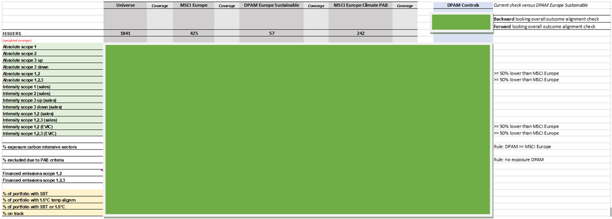
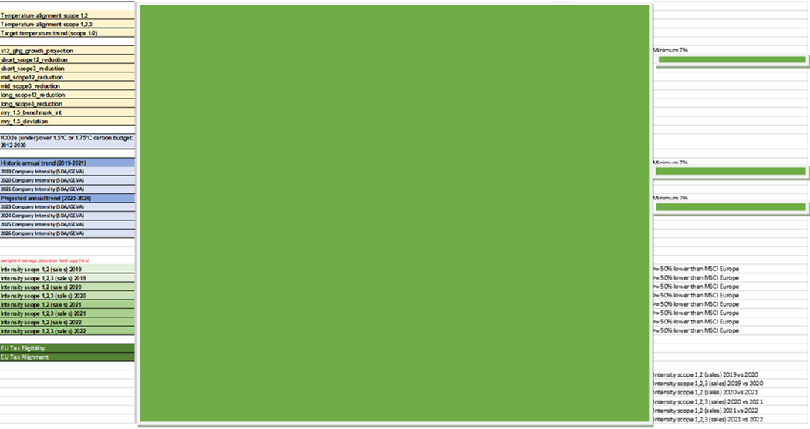

- Scenario analysis and integrated accounting explored further in 2023
Scenario analysis
According to the Financial Stability Board, scenario analysis is a tool to enhance critical strategic thinking, a way to challenge conventional wisdom about the future and a means of exploring alternatives that may significantly alter the basis for “business-as-usual” assumptions. By applying scenario analysis on different climate-related risks, an investor can make more-informed investment decisions and tackle the degree of uncertainty which is inherent to climate-related risks and opportunities, especially since those risks can vary over time, geographically and in scope.
A recent publication of the Institute for Energy Economics and Financial Analysis (IEEFA) compared the impact of climate-related risks on credit ratings from major rating agencies. Their announcements signalled that “the accumulating climate risks, though yet to result in tangible and predictable effects, will likely lead to rating volatility and instability, a costly affair for investors and issuers”. Ultimately, the robustness of ratings, if the ratings system remains unchanged, was called into question. Although not all rating volatility would be mitigated by incorporating climate risks, these would at least be accounted for.

Rating stability at risk from looming climate downgrades
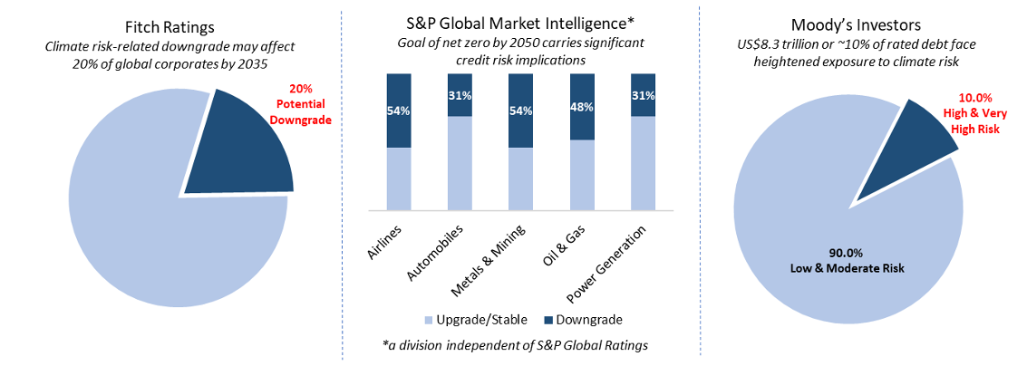
Source: IEEFA (2023)

Scenario analysis is likely the most complex, yet one of the most important pillars within the TCFD recommendations. We enhanced several tools and options to implement scenario analysis in our climate-related risk management activities and will continue to do so in 2023. Starting at issuer level, we applied the tools DPAM wide (please see section on ‘DPAM TCFD Dashboard’ above).
As scenario analysis requires specific assumptions and parameters to be assessed an industry specific focus might be required. As such, we continued to work on scenario analysis at industry and issuer level. Please also refer to section ‘1. Managing climate-related risks at company level: enhancing our TCFD dashboard’. To further enhance our capabilities, it was also decided to look for external support on climate-related stress testing, something scheduled for 2024. More information will be disclosed in our next report.
Integrated Accounting
A session was provided for the TCFD Steering Committee on integrated climate accounting as accounts are key in the value creation performance of a business, as a capital allocation guide and are linked to executive incentives. Hence, they are a good way of assessing a company’s positioning and resilience.
Following the session, the continuation of our involvement in a working group in one of our membership organisations was agreed in addition to follow-up on the matter. The issue was also raised in the introductory sessions of our dedicated TCFD or climate-risk assessments at investee level. A key question is how multiple, credible yet distinct, scenarios impact financial accounts/valuation/performance and how the assessment of transition plans can guide us in the process of answering this question.

- Climate solutions: facilitating the green transition with a climate-focused investment strategy
Climate change is leading to disruption across a wide range of sectors. Economic agents are affected and financial assets impacted. The challenges involved in moving towards a low-carbon economy are global and bring both opportunities and risks for investors that want to generate income while preserving capital.
The European Investment Bank (EIB) is aware of this and wanted to incentivise financial institutions to mobilise capital towards greener investments by issuing the first green bond (originally named ‘climate-awareness’ bond), some 10 years ago, which is a bond whose use of proceeds involve projects with positive environmental benefits. The EC even announced that at least 30% of the EUR 750 billion Recovery Fund will be raised through green bonds, which have a strong focus on climate change mitigation. The Commission is finalising the EU Green Bond Standard. The voluntary standard, built upon the Green Bond Principles, links the use of proceeds to the EU Taxonomy for Sustainable Activities (built around 6 environmental objectives). The latter is a classification system for sustainable economic activities developed in collaboration with the scientific and corporate communities, and which serves as the common language and a clear definition of what is truly ‘sustainable’. The Commission also added the external review (i.e. second party opinion) to the list of mandatory actions when issuing a green bond under its new framework.
As a result, as part of its asset allocation strategy, DPAM launched a new fixed income, thematic climate-focused investment strategy in June 2019. The objective of the strategy is dual. Channelling investments towards issuers (corporate and sovereign) that are committed to tackling climate change and seizing opportunities associated with the transition while at the same time creating an unbiased and robust bond portfolio that can weather various market conditions for investors. The fund invests in:
- green bonds issuers, i.e. financing projects that reduce emissions;
- climate challengers, i.e. issuers who are making progress towards a carbon neutral economy; and,
- climate enablers, i.e. issuers who are facilitating the transition to a carbon neutral economy.

Overall, this translates into investing in issuers whose work relates to energy efficiency, mobility and electrification, eco-society, a regenerative economy, alternative and renewable energy, land use, agriculture and water and decarbonising and manufacturing.
To ensure the investments are fit for the strategy, DPAM took proactive measures, in 2019, and developed a proprietary green bond assessment template to reduce the risk of investing in green bonds whose proceeds are not allocated to eligible, climate change mitigation or adaptation projects. Following the EU Action Plan on Sustainable Finance, apart from traditional green bonds, several new sustainable (and climate-related) financing products entered the market in 2021 (for example, transition bonds, sustainability-linked bonds, etc.). Hence, in 2021, the portfolio managers and the RICC team used the green bond template as a basis to assess newly developed use-of-proceeds or sustainability linked credit instruments, such as sustainability-linked bonds, to ensure that these fitted with the investment philosophy of the fund. In addition, portfolio managers and the RICC team are exploring and cooperating with a new specialised data provider. Its methodology aims to standardise the avoided emissions calculation, something the market and investors are still struggling with.
To ensure compliance with the framework, DPAM also engages on use-of-proceeds (credit) issuance or sustainability-linked bond issuance whenever we have concerns or identify potential misalignment with our framework and as a result might be exposed to potential reputational or financial impacts. As such, we reached out to 17 companies. These engagements tended to strengthen our initial beliefs but they also resulted in our decision not to invest in two bonds in our dedicated climate strategy due to concerns over misalignment with our requirements.
- In 2023, a UK financial player issued a green bond, associated with a framework. Although the green bond complied with several of our internal checks (for example, ICMA-alignment and second party opinion), we noticed one of the thresholds in the use-of-proceeds section was not aligned with latest EU regulatory thresholds included in the EU taxonomy, and still referred to the older, less ambitious thresholds. Given its international recognition, as well as a consultation process including industry, regulators and scientists, we decided to challenge the company on a potential downward revision of the threshold to ensure alignment with best practice, regulation and the latest available scientific consensus. Following the engagement, we received formal, written confirmation of an upcoming revision.
- In addition, in 2023, a road operator issued a sustainability-linked bond. One of the (KPI) targets was linked to a reduction of emissions intensity defined by the amounts of carbon emitted per kilometre of road operated. Following a review of the investment (capex) plans, we noticed significant capacity expansions were to be expected, impacting the denominator and hence reducing the intensity of the emissions reductions while absolute emissions would not reduce. Following an outreach which resulted in no revision of the KPI, we decided to refrain from investing in the bond for our dedicated climate strategy.
The strategy reached EUR 567 million AuM at the end of 2023.

- Climate solutions: Continuing our efforts in other asset classes
As DPAM wants to support the market for green and social bonds, for developed markets government bond portfolios, it was decided in 2021 to commit to holding a higher percentage of DPAM-validated GSS bonds (i.e. green, social or sustainability bonds approved following to a specific screening process) in portfolio than the similar reference universe, something which was continued in 2023. The table below provides an overview of our exposure.

GREEN BOND EXPOSURE (%) | EUR | % of fund
DPAM L Bonds Government Sustainable Hedged | 395,635,100 | 21.7
DPAM L Bonds Government Sustainable | 18,568,427 | 23.6
Reference Universe (OECD) | / | 1.1

More information on the policy and approach can be found here.
Furthermore, DPAM’s exposure (in mn EUR) to green bonds significantly increased over the past years, as shown in the figures below:
 | 31.12.2020 | 31.12.2021 | 31.12.2022 | 31.12.2023 | Δ2022-2023
Corporate green bonds | 443 | 824 | 828 | 1,427 | +72%
Government green bonds | 110 | 286 | 377 | 726 | +92.6%
Total | 553 | 1,110 | 1,205 | 2,153 | +78.7%

- Climate solutions: Dedicated, custom-made mandates with an eye for climate change
In addition, in terms of strategic asset allocation and product offering strategy on the institutional side (i.e. managed mandates), over the past year we have gained more experience in the development of specific climate-focused investment solutions, both in terms of portfolio management and construction, as well as in terms of climate-related disclosures (i.e. reporting aggregated climate-related metrics).
For example, for a French asset owner, we continued to develop an ESG report with detailed climate metrics such as the two-degree alignment of the portfolio and the exposure split to the different TCFD sectors, in accordance with Article 173 of the French Energy Transition Law of 17 August 2015.
During the reporting year, we enhanced our standard ESG reporting template for mandates to include more detailed climate-related information such as information on Net Zero alignment, sector contribution to portfolio GHG intensity and the top emitters by GHG emissions.


1.3. Engagement linked to climate change
In this section, more details on our engagement approach are provided, covering engagement priorities, collaborative engagements (CA100+, IIGCC, CDP), active ownership via proxy voting and via broader stakeholder engagement.
- Engagement priorities: broadening our focus
With climate-related risks and opportunities increasing, climate change has become a focal point in current debates, commitments, and regulatory actions, resulting in implications for investees and hence investors, i.e. legal, reputational and financial risks.
As climate and environmental factors and associated risks can impact companies in various ways, either directly through operations or indirectly through supply chains or end markets, credible reductions targets and an aligned business strategy to reach those targets are key. Effective corporate management entails evaluating and managing key or material environmental and social risks. Proper, transparent, and integrated reporting of these ESG risk by corporates helps investors gauge their potential investment impact, since as an investor, it is our fiduciary duty to consider these risks within the investment decision making process. It is our firm belief that companies should identify and communicate these risks to shareholders in their annual, integrated disclosures and that they should ensure consistency between the identified risk and the financial disclosures as this enables proper integration.
In recent years, companies have stepped up their climate ambitions, notably by moving from self-declared climate targets to validated science-based emission reduction targets. However, according to CDP assessments covering 2022 disclosures, of all companies with a validated science-based target, only one fifth is on track with its targets, and many do not provide a clear roadmap to reaching the target. Setting time-bound, science-based targets is a first step in the right direction, but real-economy, absolute emissions reductions must be the focus. Since climate change is impacting how companies operate, it presents financial, reputational, and regulatory risks. Disclosure criteria to enable the assessment of the credibility and feasibility of companies’ reduction pathways are key to assessing broader investment risks.
This view is shared by regulators worldwide as, apart from strengthened national climate targets and carbon pricing mechanisms globally, of particular importance is the rise of mandatory Corporate Climate Transition Plan disclosure requirements across regions, including the EU (CSRD), US (California ahead with CA SB 253 and CA SB 261), China, and the UK (Transition Plan Taskforce). These disclosure requirements are impacting the financials of corporates directly, but also indirectly through demand and supply dynamics.
As a result, DPAM, with the support of all its investment professionals, has defined science-based Emissions Target setting and Corporate Climate Transition Plan disclosures as the focus topics to represent its environmental/climate convictions and to ensure the alignment of its engagement priorities with its broader commitments.
What does this mean in practice?
To increase awareness and formulate expectations regarding the importance of credible Corporate Climate Transition Plan disclosures, aligned with international regulation and investor expectations, we would like to see the following:
- Ambition, including short-, medium- and long-term target setting with external validation, and broader supply chain commitments;
- Action, including a detailed decarbonisation plan with associated capital allocation and accounting practices, in addition to performance disclosures;
- Accountability, including governance oversight and responsibilities, remuneration alignment, policy engagement calibration and integrated reporting.

A more detailed view on our engagement priorities linked to environmentally-related values and commitments can be found in our Engagement Policy 2024.
- Collaborative engagement: CA100+: continuing our efforts through collaborative engagement
Since we became a signatory of the TCFD recommendations, in 2018, several actions were taken to strengthen our climate commitment. To further step up our commitment, we joined the Climate Action 100+ collaborative engagement initiative in June 2019 and continued to be an active member of the initiative throughout 2023.
CA100+ is a collaborative engagement initiative backed by the PRI which engages with high emitting companies on improving climate change governance, cutting emissions and strengthening climate-related financial disclosures. Over 700 investors have joined the alliance so far, representing >$68 trillion in assets under management. We were active in 2023: we participated in investor meetings, joined sessions on the development of the Net-Zero Company Benchmark and engaged with several companies.
We strongly believe that active, collaborative engagement, via Climate Action 100+ (CA100+), can facilitate the energy transition since it increases our influence and allows us to engage with our investees in a constructive way. Initially, we defined some target companies that DPAM would collaborate with as an investor, as part of CA100+. In 2020 we decided to become a co-lead investor for one of the targeted companies, a German cement producer. Since we joined the engagement, some relevant milestones have been achieved by the investees, including in 2023. In the table below, you can find an overview of some of the milestones achieved.

Company | Milestone/Company Progress | Year
French industrial gas producer | - Science-based emissions reduction target set  - Development of scenario to achieve carbon neutrality by 2050  - Development of long- and mid-term objectives to reach the 2050 goal | 2020
 | - Preliminary association review report | 2021
 | - Science-based emissions reduction target, lobbying alignment | 2022
 | - Additional GHG emissions reduction target setting (Net Zero by 2050 + Long Term);  - Commitments to Paris-aligned lobbying, including first actions that included exiting the American Fuel and Petrochemical Manufacturers group;  - Inclusion of climate elements in their executive remuneration scheme;  - Company committed to disclose a transition plan in 2024, detailing its main decarbonisation levers (efficiencies, carbon capture sequestration and electricity). | 2023
French building materials producer | - Science-based emissions reduction target set  - Net zero commitment by 2050 | 2020
 | - Net zero validation by SBTi, partnerships and SLB issuance | 2022
 | - Commitment to Paris-aligned lobbying  - Climate change performance and executive remuneration link | 2023
Irish building materials producer | - Board member with explicit responsibility for oversight of climate change  - Constructive dialogues and awareness on risk management, executive remuneration linked to climate targets, etc.  - Stated ambition for carbon neutrality by 2050  - Commitment to disclose lobbying activities in next report | 2020
 | - Commitment to Net Zero  - TCFD disclosures | 2021
 | - Absolute emissions reduction target for 2030 | 2022
 | - Decarbonisation levers disclosures  - Scenario analysis and associated disclosure | 2023
German cement producer | - Report on lobbying activities  - Commitment to align with CA100+ Net Zero benchmark requirements  - Commitment to align CAPEX with Paris Alignment | 2021
 | - Improved Policy Engagement publication + tangible actions to ensure alignment | 2022
 | - SBTi target validation  - Revised/fine-tuned Association Review Report (lobbying)  - Disclosures on revenue generated or production linked to climate solutions and targets to increase it. | 2023
Dutch food producer | - Committed to submitting a historical ‘Say-on-climate’ resolution at its 2021 Annual General Meeting | 2020
 | - Disclosure of Climate Transition Plan | 2021
 | - Improvement of short-term scope 3 target | 2022

In recent years, not all engagements went well:
- In 2019 several portfolio managers decided to divest from a targeted company, active in machinery and engine manufacturing, due to unsatisfying engagement results.
- In 2020, our engagement with a German cement producer faced some difficulties on requirements related to lobbying disclosures. As a result, the participating investors, including DPAM, decided to escalate the engagement further throughout 2021. However, following some escalation steps (and threats), an important and hopeful milestone was achieved as the company finally committed to disclose its lobbying activities/review and the alignment with its positioning reflecting the goals set out in the Paris Agreement. The commitment was met later in the year when the company published its Climate Advocacy and Association Review. Further dialogue is ongoing to address misaligned associations and align the company’s activities with CA100+’s Net Zero Company benchmark. During the reporting year 2022, the company made further improvements and published an updated Climate Advocacy and Association Review. Next engagement steps will continue to focus on alignment with the Benchmark, with a particular focus on CAPEX alignment and mid-term target setting.
- Furthermore, throughout 2022 we joined the engagement initiative targeting a French oil major as we believe it is closely aligned with another engagement initiative, we have conducted throughout 2022.
- In 2023 we continued an engagement targeting a French oil major, co-filing a shareholder proposal to ask for Paris Aligned scope 3 emissions reduction targets. Furthermore, the CA100+ company removed the assigned Board member with responsibility for climate change, making it not aligned with the Net Zero Benchmark criteria. Hence during the engagement we questioned the company’s reasons for doing so and initiated a more thorough review with potential escalation.

- Collaborative engagement: IIGCC: enhancing our engagement and research activities by joining IIGCC
At the end of 2022, DPAM decided to join an additional network active on climate change, in addition to Climate Action 100+ and CDP, the Institutional Investors Group on Climate Change (IIGCC). This is the European membership body for investor collaboration on climate change.
The organisation aims to:
- Shape sustainable finance and climate policy, and regulation for key sectors ;
- Support market development to facilitate investor action on climate change ;
- Guide investors in managing climate risks and opportunities and aligning portfolios to climate goals ;
- Accelerate investment in climate solutions;
- Drive net zero business strategies and support real economy impact through stewardship and sector-level engagement;

We strongly believe joining this initiative will accelerate our engagement and research efforts regarding net zero, in addition to the other environmental convictions we defend. As such, in 2023 we joined an engagement initiative which broadens the target company scope for Net Zero alignment (linked to CA100+ initiative), ultimately aiming at alignment with the Investor Expectations of Corporate Transition Plans.
During the year, we engaged, in collaboration with other investors, with multiple companies.

- Collaborative engagement: CDP, encouraging transparency and SBT setting
By signing an agreement with the dedicated carbon data provider Trucost, we are able to broaden the scope of our assessments since it allows us to access modelled data and additional indicators. However, we believe that the integration of climate-related risks via the TCFD recommendations (and the dedicated internal assessment template) requires company reported data as well, ideally via standardised reporting. Hence, DPAM became a CDP signatory in December 2019/January 2020. As a reminder, CDP is a not-for-profit charity running the global disclosure system for investors, companies, cities, states and regions to manage their environmental impacts. By becoming a member, we gained access to company specific data since companies can disclose climate, water and forest related information to the CDP via a standardised questionnaire, which is later shared among signatories. We believe this can significantly increase insights into companies’ climate strategy and governance quality and hence improve our fundamental research.
To urge companies to disclose to the CDP, the organisation launched the ‘Non-disclosure Campaign’ (NDC), targeting companies who failed to disclose in the year prior to the target year. We joined the campaign in 2020 and renewed this action in 2021 and 2022. Since the CDP is the leading carbon disclosure body, becoming a signatory strengthens our commitment and can facilitate our individual climate-related engagement actions. DPAM signed up to take a lead on engagement for several companies. In addition, we believe these disclosures provide information for the wider stakeholder community and have the benefit of requiring corporates to measure and rethink environmental implications. But how did the 2023 campaign perform?
The 2023 campaign reached out to 1,590 companies and had an overall response rate of 19.9% - significantly below 2022 results, which was the highest in the campaign to date. Nonetheless, the 2023 results demonstrate yet again that companies were more likely to disclose when engaged with directly by investors. DPAM managed to get a 26% response rate, above the average of 19.9% which we consider a positive sign from our investees.
For the remaining targeted companies not yet disclosing, we ensured a constructive follow-up conversation to share our concerns and expectations. For some investees, we did not receive a (positive) reply. Those companies will be targeted again next year.
Below we provide some details on DPAM’s role in the CDP Non-disclosure Campaign 2023. Overall, these results are slightly below 2022 NDC results, aligned with the overall campaign results.

DPAM Role | Total Engagements |  |  | Successful Outcome*
 | 2023 | 2022 | 2023 |  | 2022
Lead | 31 | 46 | 26% |  | 33%
* I.e. company submitted the questionnaire

Note that as of 2023, the NDC changed its approach, focusing on lead investors only, and leaving out those that co-signed.
As an EU-based asset manager, we focused our efforts on EU and US companies, but also target more Belgian based companies. The geographical split of target companies from the total CDP NDC campaign clearly shows an increased focus on US and EU companies (likely linked to regulatory pressures), but also a rise in disclosure requests for East Asian corporates, as global warming effects become increasingly tangible in those regions.

Furthermore, financial services and entertainment rank among the top industries targeted by our engagement activity.
In addition to the NDC, DPAM also took part in the Science-based Targets Setting Campaign, which encourages companies to set carbon emissions reduction targets in a scientifically backed manner, which are later validated by an external organization (the Science-based Targets Initiative). Similar to last year, we saw the increasing interest of companies to set such targets which is promising, as part of a broader target setting approach, identified at portfolio level (see further in section ‘Metrics and Targets’). For the 2023 SBT campaign, over 1,000 companies were targeted by a large group of investors and urged to consider science-based target setting. By the end of 2023, slightly more than 10% of the companies approached committed to setting a science-based target, while almost 20% are assessing feasibility or have indicated they will likely commit to the initiative.
Note that our climate engagement approach also focuses on individual engagement (i.e. companies in the framework of our TCFD analysis, see section ‘TCFD aligned climate risk assessment approach – DPAM proprietary assessment sheet’) in addition to collaborative engagement. For individual engagement, it is at the discretion of the portfolio manager and analyst to assess the outcome of their dialogues with the company and to what extent the company in question is sufficiently addressing climate-related risks or seeking climate-related opportunities (i.e. engaging in dialogue to improve the quality of the fundamental research). Although we do believe these dialogues have the capability of resulting in real economy impact, these are not yet measured and no formal escalation procedure is applied unless initiated by the portfolio manager.

- Active ownership: Proxy voting as a means for climate action
As described in our voting policy, we have a dedicated approach to climate-related proxy voting. Being a responsible investor, DPAM fully supports shareholders’ and managements’ ESG-related proposals, in alignment with its global commitment. This includes:
- Signing the 6 Principles of Responsible Investment, which were backed by the United Nations in 2011;
- Supporting the TCFD recommendations and being a signatory of the Climate Action 100+ initiative, which promotes climate risk oversight by the board of directors;
- Recently joining the Net Zero Asset Management (NZAM) initiative, committing to achieving net zero greenhouse gas emissions by 2050 or sooner;
- Adhering to the OECD recommendations regarding the social and environmental responsibility of companies;

Social, environmental and economic objectives must be integrated into the company’s goals, and the Board of Directors’ primary mission is to uphold them. In addition to assessing the commercial and reputational impact of the company’s activities, the Board of Directors must also understand their environmental and social implications. To achieve this, management must ensure that the necessary procedures and controls are in place.
DPAM considers a company to be managed in a responsible and sustainable fashion when it is managed in accordance with applicable corporate governance rules, when its human capital is at the heart of its interests and not exclusively seen as a cost item, and when it respects the environment in which it operates. Hence, linked to climate-related voting activities, we defined two cases, for which recommendations have been provided to our Voting Advisory Board (please also refer to our Voting Policy):
- Case-by-case voting on ESG and Climate Risk Management
- ESG shareholder proposals (SHP)

Case-by-case voting on ESG and Climate Risk Management
Effective corporate management entails evaluating and managing key or material environmental and social risks. Proper, transparent, and integrated reporting of these ESG risks by corporates helps investors gauge their potential investment impact, since as an investor, it is our fiduciary duty to consider these risks within the investment decision making process. Hence, it is our firm belief that companies should identify and communicate these risks to shareholders in their annual, integrated disclosures and ensure consistency between the identified risk and the financial disclosures to enable proper integration.
Stemming from DPAM’s climate risk approach to implementing the TCFD Recommendations and its escalation tactics as defined in its Engagement Policy, we defined a more targeted approach within our voting activities. Following internal assessments and dashboarding tools to assess the performance of our investees on the principles of proper climate risk management, integrated accounting, aligned remuneration and executive oversight and accountability, case-by-case voting escalation actions might be undertaken:
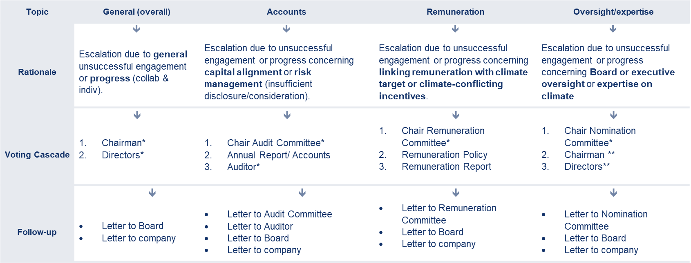
* Only re-election votes
** New nominees in case already missing expertise in Board + no additional insights

ESG shareholder proposals (SHP)
Generally, DPAM tends to support shareholders’ proposals when these are aligned with its global engagement for example, aligned with: DPAM’s objective to defend fundamental rights (Global Standards); DPAM’s controversial activities policy; DPAM’s engagement priorities; and DPAM’s global commitment to NZAM.
As shareholders’ proposals can be diverse, comprehensive guidance on how our voting principles are implemented cannot be exhaustive. Proposals will require regular case-by-case analysis, where DPAM will be attentive to the following criteria of the SHP: materiality; engagement outcomes; current company performance on the topic and the company’s required actions.
In terms of the environment, particularly the climate, the proposals will be assessed within the framework of our climate commitment. This includes examining whether the proposals encourage transparency, carbon disclosure, and strategies that align with the Paris Agreement. DPAM will also consider whether the proposal sets a net zero target/ambition, with short term and intermediate targets established in line with the Paris Agreement, and whether it is scenario-based and aligned with the Taskforce on Climate Financial Disclosures (TCFD) recommendations.
In 2023, 21.7% of all the Shareholder Proposals we voted on were linked to the environmental theme (totalling 83 proposals). In line with last year, we voted in favour of the vast majority (96.4%) of these shareholder proposals, which requested companies to align with the Paris Agreement and net zero by 2050 or sooner, to disclose and reduce their Scope 3 emissions, publish TCFD reports for M&A and Direct Lending, Net Zero CAPEX alignment, disclosure of a climate lobbying report, auditing of asset retirement obligations, etc. Target companies included amongst others Amazon, TotalEnergies, Berkshire Hathaway and Engie.
Recent evolutions in the field of climate-related resolutions, such as the Say-on-climate resolution, require us to take action. Say-on-climate resolutions are modelled on “Say on Pay” votes, where shareholders cast a non-binding advisory vote on a company’s executive compensation package at the company’s annual meeting, but in this case the focus is on climate strategy or progress.
To tackle this type of vote, our Voting Advisory Board, in charge of the voting policy of DPAM, was informed of the rise of these resolutions, and in 2021, in close collaboration with the TCFD Steering Committee, initiated a process to define a voting approach to assess this specific type of resolution. In 2022, the TCFD Steering Committee made a formal suggestion, later validated and approved by the Voting Advisory Board. DPAM will engage in dialogue with the company on all Say on Climate proposals, whether they come from management or shareholders. In 2023, these criteria were updated and fine-tuned to align with latest market practices and expectations.

Regarding Climate Transition Plans, the assessment indicators comprise the following:
- A corporate commitment or ambition to achieve Net Zero by 2050, covering all relevant GHG emissions.
- Medium-term targets that align with the 1.5°C scenario or which have been validated and recognised by the SBTi (Science-Based Target initiative) for scope 1 and 2 GHG emissions and relevant scope 3 GHG emissions.
- A decarbonisation plan that includes a quantified strategy, detailing capital allocation alignment, climate risk, accounting disclosures/considerations, resilience and alignment with a 1.5°C scenario and auditor references).
- Public disclosure of reporting that aligns with the TCFD recommendations, included in the Annual Report and Accounting Principles.
- An indication or/disclosure on the consequences and implications of the voting outcome (for example, advisory/binding nature).
- Linking executive remuneration/compensation to the climate targets (STIP or LTIP), without conflicting performance-related pay criteria.

Regarding the Report on Climate Transition Plans, the assessment indicators comprise the following:
- Evidence of a year-on-year short-term carbon (equivalent) intensity or absolute reduction; or alternatively evidence of a long-term carbon (equivalent) intensity or absolute reduction, compounded over three years;
- Progress against the reduction trajectory implied by existing GHG emission reduction targets;
- Operational emissions progress (for example, separate assessment of operational emissions progress against an intensity indicator);
- A publicly disclosed reporting aligned with the TCFD recommendations, included in the Annual Report and detailing at least capital allocation and accounting considerations; and
- An indication or disclosure of the consequences and implications of the voting outcome (advisory/binding nature).
In close cooperation with the research carried out on issuers regarding their climate strategy, the voting guideline will be to vote abstain in the first year to encourage the company to adopt the indicators in their transition policy. If, in coming years, the elements, set out above, are not present, then DPAM will vote against.
An engagement letter has been sent out to companies with a Say-on-Climate resolution at their 2023 AGM (regardless of our voting decision) and DPAM will continue this process for the 2024 AGM season. As such, six letters were sent out in 2023, a decrease from the 2022 figures as companies and shareholders refrained from putting the plans to a vote. An example of such an engagement can be found below.


Company | Vote Decision | Rationale
Spanish infrastructure company | Abstain | - Company provides only a purely qualitative and overly-broad assessment of the scenario analyses that it has undertaken.  - No information concerning capital expenditures  - Missing view on the Board's role in overseeing strategy (including consideration of past votes) and consideration of the current voting outcome.

In 2023, DPAM co-filed 5 climate-related shareholder resolutions. Four of the resolutions requested oil and gas companies to align their existing 2030 reduction aims covering the greenhouse gas (GHG) emissions of the use of their energy products (Scope 3) with the goal of the Paris Climate Agreement: to limit global warming to well below 2°C above pre-industrial levels and to pursue efforts to limit the temperature increase to 1.5°C. To do so and align with the above-mentioned actions to increase to the ambition of oil majors, DPAM joined actions taken by FollowThis, an organisation uniting shareholders to push big oil to transition and move beyond business as usual. In addition, DPAM co-filed another resolution at Engie, a French Utilities company, requesting a modification of its articles of association, in order to include the possibility of submitting a consultative vote every three years on its climate strategy and every year on its implementation. Note that co-filing is often combined with both corporate and proxy voting advisor outreach to detail the proposal and rationale.
Finally, on the governance side, in full alignment with the TCFD and Climate Action 100+, DPAM supports Boards that oversee ESG-related risks and opportunities. Section 2 “Sound corporate governance, role and composition of the Board of Directors” details the key requirements in terms of corporate governance. Nevertheless, other broader governance topics might be voted on, too. These can be related to business ethics and integrity, tax strategy or supply chain management, to name a few.
It should also be noted that recent years have been characterised by a rise in so-called ‘anti-ESG/anti-climate’ shareholder proposals, Harvard Law School have estimated a fivefold increase in the past three years (from eight in 2021 to 52 in 2023). These proposals are sceptical of corporate environmental, social and governance initiatives and are often not aligned with SRI objectives and are currently receiving limited support as seen in the 2023 Voting Season results (estimated average 2.8% support). To ensure we align our voting activities with our SRI commitments, we should remain vigilant of SHP proposals. Hence, a case-by-case analysis of SHP proposals is required to ensure we vote in line with our fiduciary duties (and integrated SRI commitments and objectives). As such, we support shareholders in nearly 82.72% of cases but voted against resolutions in 14.57% of cases. The vast majority of shareholder proposals we voted against were anti-ESG proposals.

- Active ownership: Broader stakeholder engagement
Beyond corporate engagement, DPAM is also committed to defending its values and convictions through engagement with other financial stakeholders. As mentioned in the Engagement Policy, DPAM mainly focuses on actions led by collaborative engagement initiatives (CA100+, IIGCC, FAIRR). Actions taken throughout 2023 include amongst others:
- Joining dedicated webinars to share knowledge and experience (for example, use of CDP-reported climate data);
- Participating in the development and publication/sharing of investor expectations or concerns (for example, climate stress testing);
- Proxy Voting Advisor outreach (for example, discussing the approach to Say-on-Climate voting recommendations, exchanging net zero proxy voting insights, co-signing public letters to enhance climate advice).

1.4. Knowledge sharing

As a responsible investor, we also value knowledge sharing. Throughout 2023, we shared several articles, blogs and videos on climate change. We provided insights on our approach to climate risk and engagement at a Pan-European conference (link), Belgian event for the insurance industry and a US investor focused webinar, we had an article published on the renewables market (link), gave an interview on climate transition planning and our associated sustainability conference (link 1), and shared updates during and after COP28 (link 1).

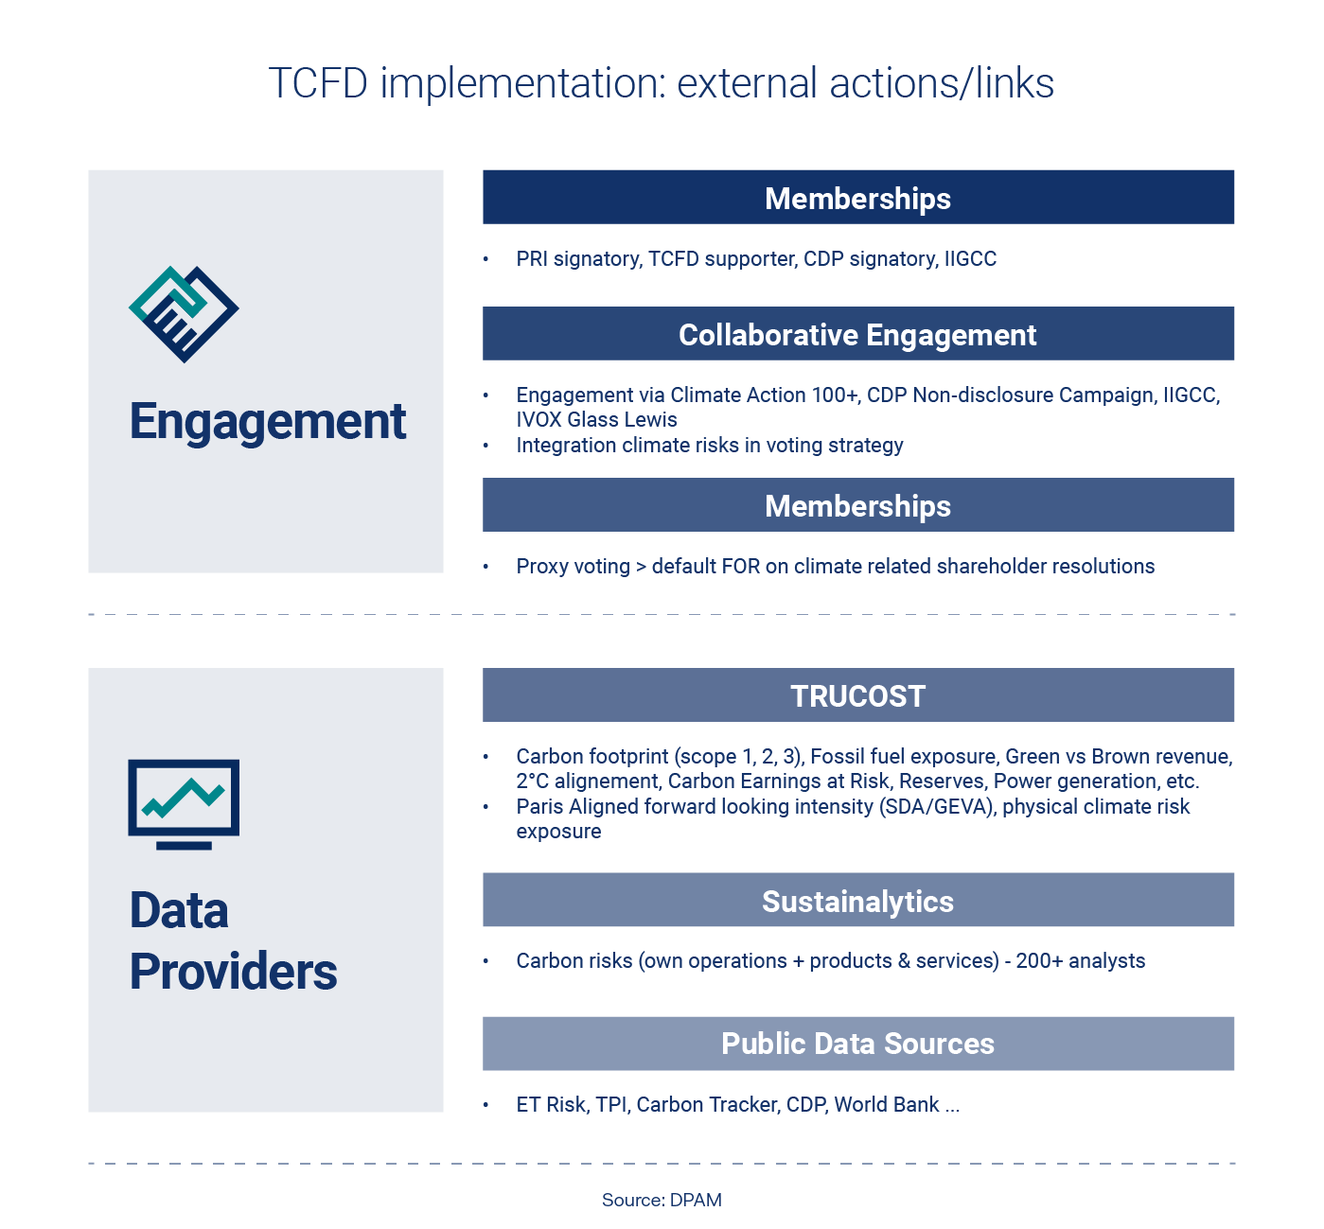

- Metrics & Targets

- Metrics: increasing our reporting capabilities, aligned and beyond regulatory requirements
DPAM started disclosing the carbon intensity of its portfolios in June 2017, on a quarterly basis. The carbon intensity of the portfolio is meant to assess the portfolio’s carbon risk in the framework of the transition to a low-carbon economy. In order to do so, the carbon emissions of the various issuers are calculated and reported based on their total revenue. The calculation method is based on the acknowledged methodology of the Global Greenhouse Protocol and takes into account scope 1 and scope 2 emissions, and since 2023, scope 3 up- and downstream emissions.
The carbon intensity is eventually calculated as a weighted average of the carbon intensity (in tCO2e/$M revenue). Additionally, for our dedicated sustainable strategies, the top 5 emitters and contributors to the overall carbon intensity of the portfolio is disclosed. An example of such disclosures, via our Quarterly Sustainability Reports for SFDR art. 8+ and 9 funds, can be found below.

Disclosing carbon intensity details in our Quarterly Sustainability Reports
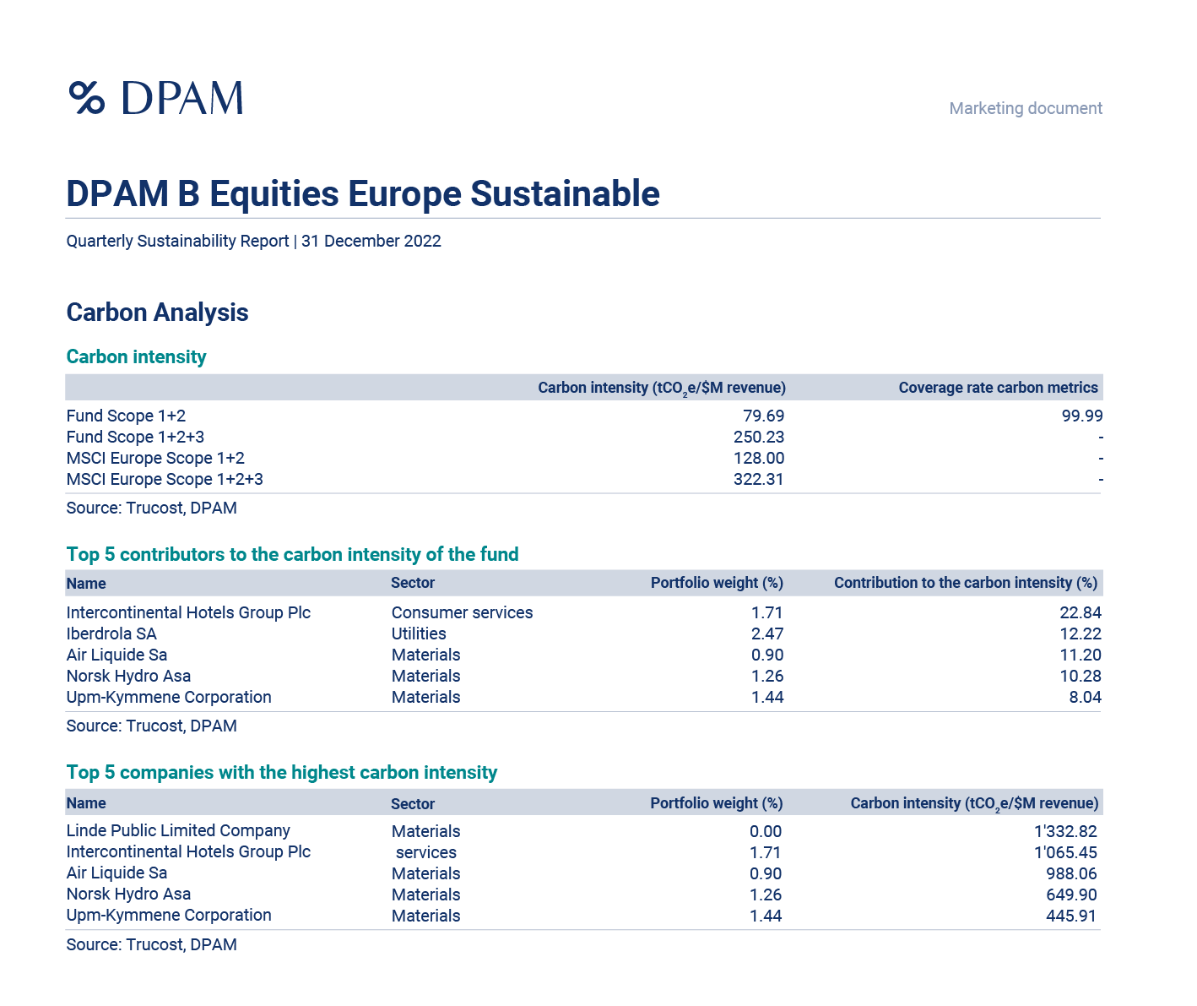
Source: DPAM

Our disclosure of climate-related metrics evolved further in 2023, given regulatory evolutions in the field of sustainable finance, i.e. the Sustainable Finance Disclosure Regulation. One of the requirements concerns the disclosure of so-called Principle Adverse Impact (PAI) Indicators. These indicators tackle all the sustainable investment pillars (environment, social and governance). On the environmental side, several indicators are linked to climate change (for example, investees’ scope 3 emissions and fossil fuel energy use). Our experience with ESG reporting and our preparatory work throughout 2021 and 2022 enabled us to meet the upcoming disclosure requirements of the SFDR regulation in 2023. So, what has been reported?
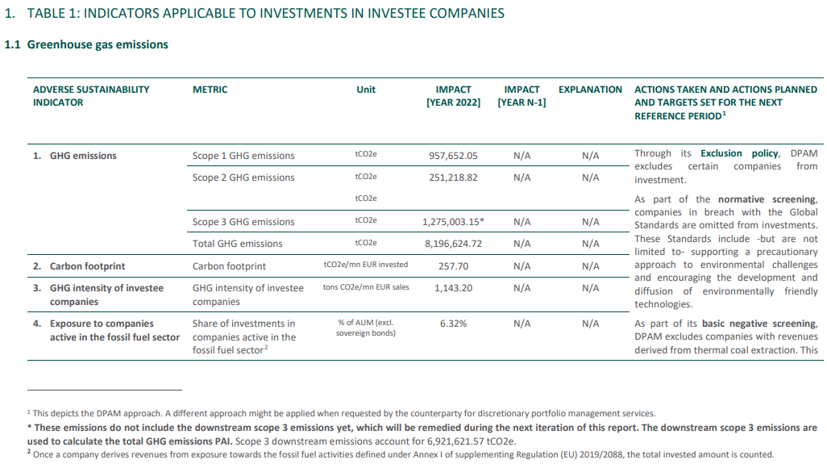
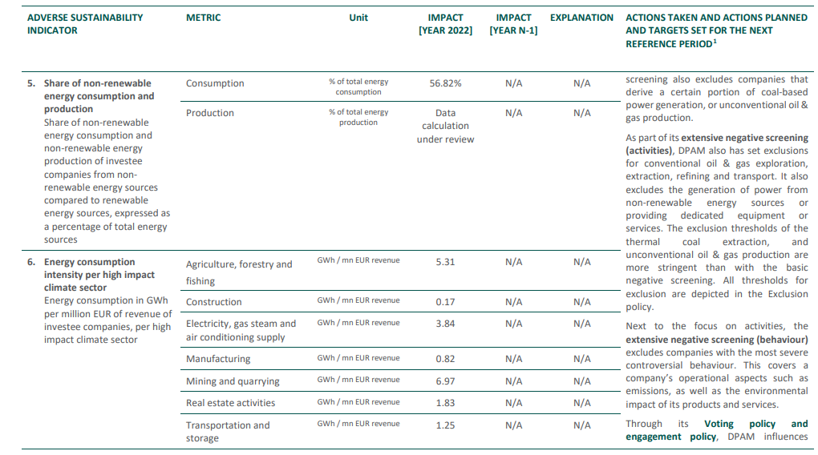

More information on climate-related PAI integration, data providers, methodologies and calculations can be found in here.
In addition to metrics related to GHG emissions, EU Taxonomy regulation also requires financial institutions and corporates to disclose the alignment with the sustainable activities defined in the regulation. Disclosures were made throughout 2023, in periodic reporting.

- Targets: SFDR, Controversial Activities, and the road to Net Zero
During the reporting year, carbon emissions-related target setting at portfolio level has been further monitored and implemented. As such, for all SFDR-classified article 8+ and article 9 funds, a target has been implemented to either attain a portfolio carbon intensity (scope 1, 2 and 3 emissions) below the average carbon intensity of the reference universe before the sustainable investment selection methodology was applied, or to attain a science-based targets coverage (or equivalent) of the portfolio above the one of the reference universe before the sustainable investment selection methodology was applied. A third alternative is an absolute science-based targets coverage target by 2026. The attainment of these targets was monitored further in 2023, allowing us to finetune or enhance investment decision making processes, such as engagement with investees or proxy voting. This includes portfolio level pre-trade monitoring and post-trade monitoring, next to quarterly monitoring via the TCFD Steering Committee meetings.
Note that several investment managers also indicate targets linked to fossil fuel exposure or the decarbonisation of power generating companies. Although not specifically linked to a target as such, DPAM implements eligibility criteria linked to high-carbon activities, such as oil and gas, coal and power generation. More details can be found at section 1.5 ‘Strengthening portfolio construction criteria’ or in our Controversial Activities Policy, via the following link.
The Glasgow Financial Alliance for Net Zero (GFANZ) was launched in 2021 and combines actions within the financial industry, such as the Net Zero Asset Managers initiative and the Net Zero Asset Owner Alliance (see figure below). These initiatives, in particular the former, will impact and guide DPAM’s climate and investment strategy, as we consider it our fiduciary and societal duty to do so.

Net Zero Initiatives Map
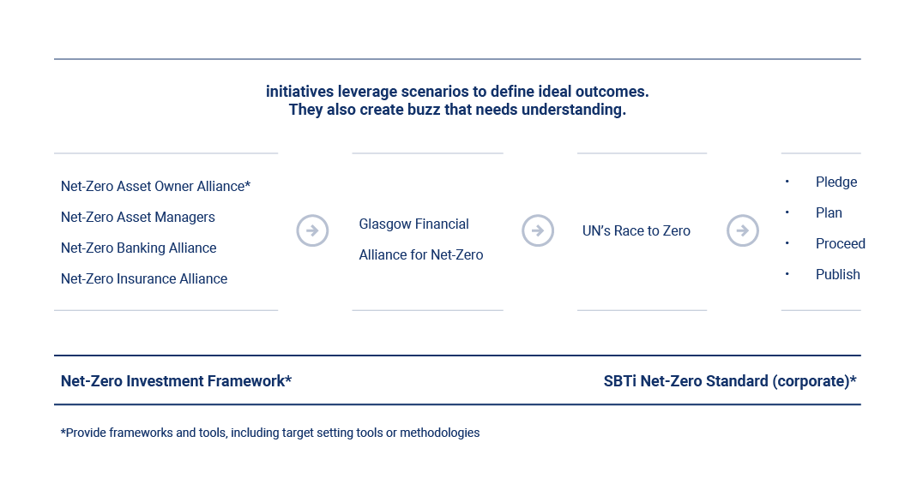
Source: GFANZ

DPAM sees the net zero objective as ambitious and impactful, we believe it deserves serious and firm commitment in relation to the consequences and a detailed path, including milestones, to ensure the result by 2050. Knowing engagement on corporate emissions reduction target setting will be a key pillar of the commitment, our collaborative engagement initiatives with investees strongly focus on the crucial role of setting (science-based) emission reduction targets.
As the ‘below two degrees’-alignment of a portfolio depends on its constituents, we strongly believe these actions should be prioritised (note that the Science-based Targets initiative also recognises investee engagement on science-based target setting as a key pillar for investor target setting). As such, in 2021 and 2022, an assessment trajectory has been initiated by our TCFD Steering Committee to evaluate the impact of net zero-targeting on investment decisions and -universe and on commitment to the Net Zero Asset Managers initiative. The variety of existing standards, expectations, pathways, methodologies and tools results in different types of targets being set by financial institutions, with implications for investment trajectories and performance. Hence, to ensure we have a clear view on all the implications, a thorough feasibility assessment for joining the Net Zero Asset Managers Initiative was decided on.

The internal assessment, which took place in 2021 and 2022 studied feasibility broadly and included: financial feasibility; investment risk implications; legal compliance; data accuracy and availability; the scientific basis and practical implications. More concretely, the assessment process consisted of:
- An assessment of the concepts of ‘Paris Alignment’ / ‘Net Zero’ / ‘Science-based Targets’ for financial institutions (i.e. implications), based on reputed/internationally recognised standards;
- The assessment and selection of appropriate tools/sources for portfolio assessment (including best practice), aligned with the above;
- Data gathering, including the selection of appropriate providers, where required and data availability assessment;
- A trial/test of the selected tool(s), sources and methodologies;
- An assessment of data accuracy and limitations as well as use cases (integration in investment decision making, extended reporting, regulatory obligations);
- An assessment of the implications of converting portfolios to the requirements as identified in the steps above, for example, asset allocation consequences, financial feasibility, investment risk implications (VaR), asset concentration, green bubbles, overvaluation, etc.;
- Formal recommendations of the TCFD Steering Committee to DPAM’s Management Board;
- Decision by DPAM Management Board.

The feasibility study resulted in a formal commitment to the Net Zero Asset Managers Initiative in March 2022, validated in November 2022. More information on the target can be found in the figure below or via following link or publication.

DPAM’s validated Net Zero Commitment
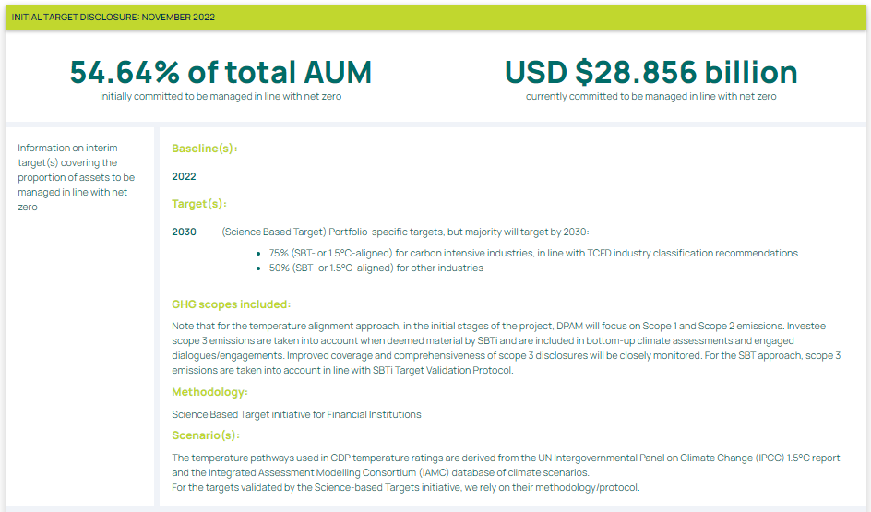
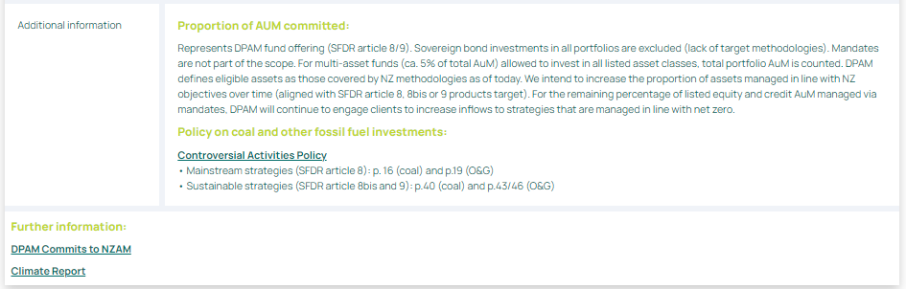
Source: NZAM

At the DPAM aggregated level at 31.12.2023:
KPI | Target | Percentage
Net zero – Proportion of DPAM Corporate AuM with SBT or 1.5°C Alignment | Net Zero 2040 | 57%

Additionally, the table below depicts DPAM corporate holdings according to SBT commitments and validation (31/12/2023*):
SBTi status | % of total DPAM Corporate AUM
Approved | 47%
Committed | 17%
Not committed | 36%
* based on SBTi database consultation February 2024
To conclude, in the process of studying the feasibility of committing to the Science-Based Targets initiative in 2023 we tracked developments of the SBTi Guidance for Financial Institutions, something on which we hope to take further steps in 2024.
Note that also the group Bank Degroof Petercam was inspired by DPAM’s net zero journey and hence made a voluntary net zero commitment.
Finally, we also checked the alignment of DPAM’s climate integration approach to the GFANZ framework, upon recommendation of one of our membership organisations, and identified some positive alignment. More information is provided in section ‘FROM TCFD TO GFANZ’.

Comparing GFANZ’s FI Net Zero Transition Plan framework and DPAM’s TCFD approach
GFANZ financial institutions net-zero transition plan framework
DPAM net-zero transition plan implementation
Source: GFANZ; DPAM



- A process of continuous improvement

- Looking back: some first milestones achieved
In previous years, DPAM achieved some of the milestones in the journey towards implementing the TCFD recommendations.
Implementing the TCFD recommendations: what has been done so far?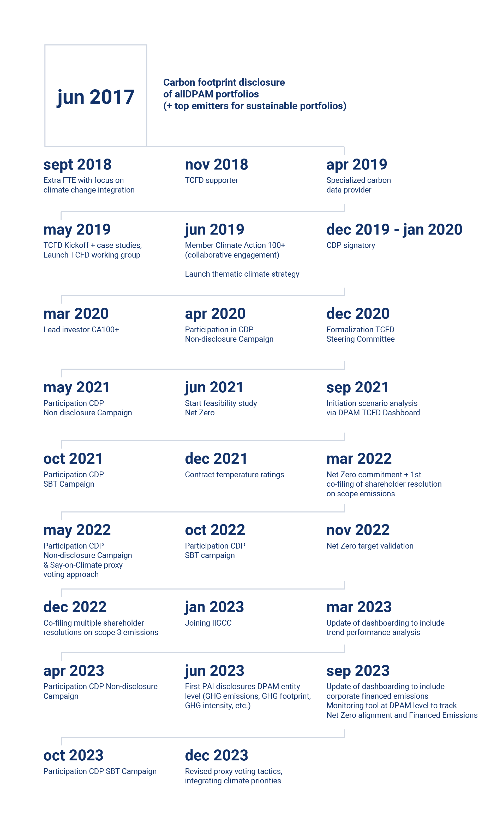
- Looking forward: further improving our climate-related risk management techniques
Strategic asset allocation (and the review of this process) is an integral part of the TCFD implementation process for asset managers. Apart from the climate risk assessments on issuer level, developing climate-focused investment strategies and developing and expanding a TCFD exposure dashboard were first steps to diversify our investment activities and strengthen our risk management approach. But as the implementation of the TCFD principles is a complex and a multi-year process, and since there is a large spread in plausible climate scenarios, continuous improvement is key. Hence, in coming years, DPAM plans to improve its TCFD implementation process by broadening the scope of its assessments on different levels:
- further exploring scenario analysis at individual position, portfolio and DPAM level to assess vulnerability to different climate scenarios, especially in light of upcoming regulation within the financial industry, already targeting banks, insurers and other investors. This will include stress-testing;
- strengthening the integration of climate-related elements in strategic asset allocation and risk management activities, amongst others by exploring the feasibility of a climate/ESG VaR and macro analysis; and,
- continuing our work to further work towards our climate-related targets at DPAM and portfolio level.

TCFD integration in overall Risk Management
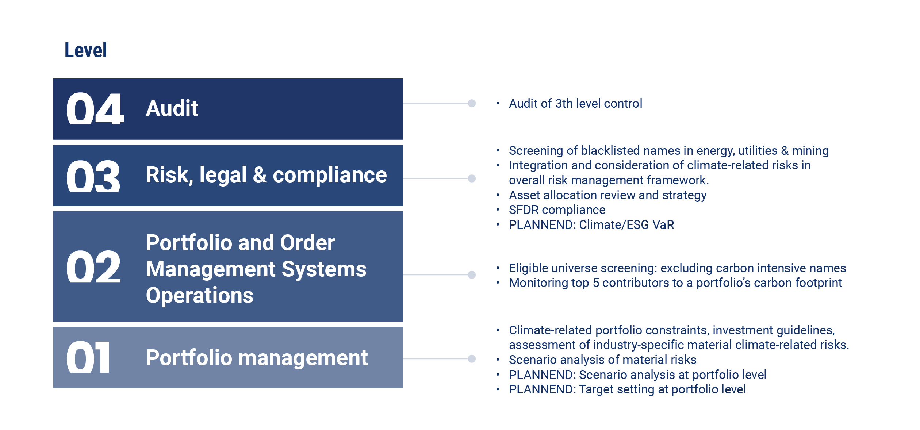
Source: DPAM

- Integrating the TNFD principles

- Biodiversity loss in the spotlight of investors and regulation
The increasing focus on nature-related issues, particularly the decline in biodiversity, reflects a growing recognition of the interplay between ecosystem health and our planet's capacity to tackle climate change. This heightened attention extends to the European sustainability reporting landscape, notably with the adoption of the Corporate Sustainability Reporting Directive (CSRD) as part of the European Green Deal in April 2021. Within the European Sustainability Reporting Standards (ESRS), which underpin the CSRD, ESRS E4 (Biodiversity and Ecosystems) six reporting requirements are included to provide a detailed understanding of a firm’s nature-related impacts, dependencies, risks, and opportunities. This European Sustainability Reporting Standard builds further on the guidance framework from the Taskforce on Nature-Related Financial Disclosures (TNFD). Through their disclosure recommendations, the TNFD encourages and will enable businesses to report, assess and more importantly act on their nature-related dependencies and impacts.

Understanding biodiversity's broader environmental implications is imperative, given its interplay with climate change, pollution, land and sea use, and other factors. The TNFD emerges as a pivotal framework, complementing existing efforts such as the Task Force on Climate-related Financial Disclosures (TCFD). By underscoring the integral relationship between climate and nature-related risks, the TNFD advocates for a holistic environmental risk management approach.

The TNFD is built on the same four pillars as the TCFD, resulting in a significant overlap to facilitate a seamless integration of nature-related aspects into existing reporting frameworks. Leveraging our current TCFD disclosures, DPAM aims to extend our reporting to cover nature-related risks and dependencies, providing stakeholders with a comprehensive understanding of our environmental impact.
The Kunming-Montreal Global Biodiversity Framework (GBF), that was adopted at COP15 in 2022, presents an ambitious plan for a world in harmony with nature by 2050. The Framework includes 23 targets for 2030 and emphasises the urgent need for immediate action. The GBF reinforced our conviction to increasingly focus on biodiversity risks and opportunities in our investment decision making process.



- DPAM’s commitment to adopt the TNFD recommendations

Following our support for the TCFD recommendations, DPAM is proud to announce that we are among the inaugural TNFD Early Adopters. The full cohort was announced in early January 2024, in Davos, at the World Economic Forum Annual Meeting. As an Early Adopter, DPAM signals its intent to start adopting the TNFD recommendations and publish TNFD-aligned disclosures in our corporate reporting by financial year 2025. With over 320 organizations from over 46 countries having committed to making nature-related disclosures, there is a growing momentum behind TNFD which underscores the increasing recognition for the TNFD from stakeholders, regulators, and financial institutions worldwide.
The Kunming Montréal Global Biodiversity Framework (GBF) is to biodiversity what the Paris Agreement is to climate. The alignment between the GBF and the TNFD therefore reinforces DPAM’s commitment to biodiversity conservation and sustainable practices. By adhering to this disclosure framework, we not only fulfil reporting obligations but also contribute to broader global biodiversity goals, demonstrating our dedication to environmental stewardship.
In conclusion, our decision to integrate nature-related financial disclosures into our TCFD reporting reflects our proactive stance on environmental risk management and commitment to transparency and sustainability. We stand ready to navigate the evolving landscape of environmental reporting, to leverage frameworks like the TNFD and to align with global biodiversity initiatives to foster positive change and cultivate a more sustainable future.

As mentioned above, the TNFD will follow the structure of the TCFD framework and its four pillars:
- Governance: focuses on board oversight and the role of management.
- Strategy: focuses on effects on the business model, strategy and its link with asset allocation and performance assessment.
- Risk Management: includes risk materiality assessment, risk measurement, prioritisation, and monitoring.
- Metrics and targets: focus on the use of metrics to understand and manage material dependencies, impacts, risks and opportunities.

As with the TCFD, the implementation of the TNFD principles is a multi-year process. However, we expect the adoption to occur at a faster pace, as the setup of the TCFD can be leveraged. Below, the overlap between the TCFD and the TNFD is depicted with 11 of the 14 recommendations being carried over from the TCFD.

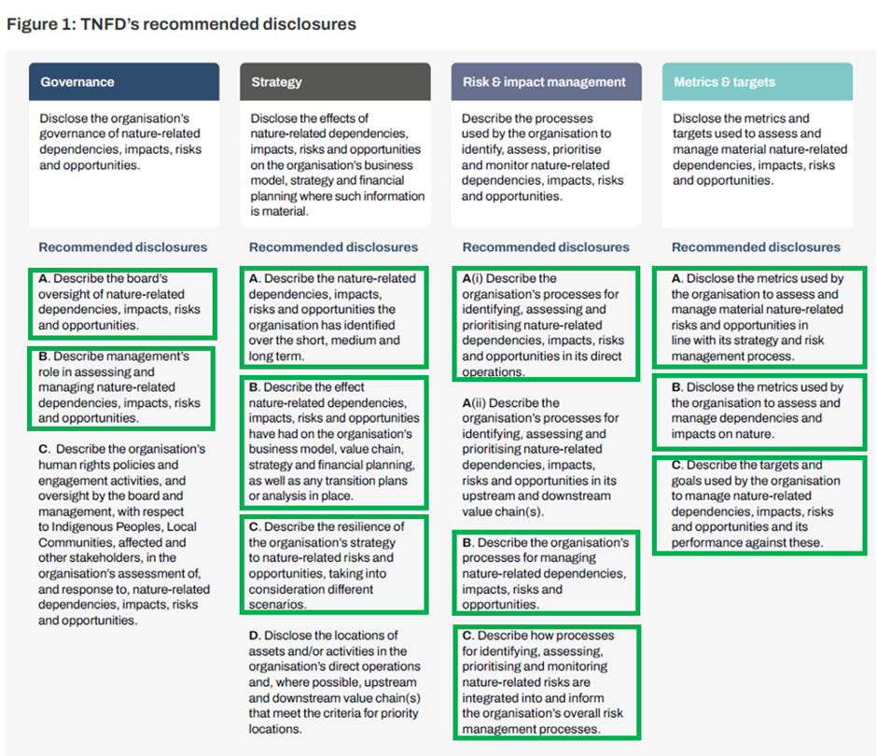
Source: TNFD, green boxes are carried over from the TCFD

  - Governance
The governance framework will remain the same as for the TCFD, see above.

  - Strategy and Risk Management
From a strategic and risk management perspective, the RICC will perform an initial sector exposure assessment for the most material nature-related risks, this will form the starting point for risk identification. The assessment, which will be based on reports and data coming from external experts (for example, Planet Tracker, Forest 500, World Benchmarking Alliance) and data providers (selection process ongoing), will focus on the risk exposure for our investees.
To further strengthen our commitment, DPAM was also one of the initial signatories of Nature Action 100. Similar to Climate Action 100+, Nature Action 100 is a collaborative engagement initiative that aims to drive greater corporate ambition to reverse nature and biodiversity loss. The assessment framework is based on 6 pillars:
- Ambition: make public commitments to conserve and restore nature at the operational level and throughout value chains by 2030.
- Assessment: assess and publicly disclose nature-related dependencies, impacts, risks, and opportunities.
- Targets: set time-bound science-based targets and disclose annual progress against these targets.
- Implementation: develop a company-wide plan on how to achieve targets. Disclose annual progress against the plan.
- Governance: establish board oversight and disclose the management’s role in assessing and managing nature-related dependencies, impacts, risks, and opportunities.
- Engagement: engage with external parties including actors throughout value chains, trade associations, policy makers, and other stakeholders

To define the scope of the 100 target companies, an assessment was made by the Finance for Biodiversity foundation, which used different biodiversity foot printing approaches to determine the companies with the highest impact. However, to avoid duplication of effort (for example, companies in scope of CA100+), sectors like oil and gas were not covered. The table below provides an overview of the sector distribution:

Sector | # companies covered | DPAM scope (co-lead)
Industrials | 4 | /
Health care | 10 | 1
Consumer Staples | 43 | 2
Consumer Discretionary | 9 | /
Materials | 32 | 1
Information Technology | 1 | /
Real Estate | 1 | /

In 2024 engagement will be initiated for the target companies.
Furthermore, DPAM is also an investor endorser of Spring, the UN PRI’s stewardship initiative for nature.
Finally, DPAM’s efforts through collaborative engagement initiatives and the implementation of the TNFD principles reflect DPAM’s commitment to make a positive contribution to biodiversity through our investments and activities, which is aligned with the Finance for Biodiversity Pledge that we signed in 2020.

  - Metrics and Targets
For financial institutions, incorporating biodiversity considerations into investment processes is essential due to both physical and transition risks. Companies that are dependent on nature face risks such as supply chain disruption and regulatory scrutiny, necessitating a closer examination of biodiversity impacts. The private sector therefore, has a key role to play in financing biodiversity and nature-positive business models and limiting negative impacts. But to invest accordingly, data is required.
Data on biodiversity impacts and dependencies is crucial for informed decision-making in investment strategies. However, selecting appropriate data sources presents challenges due to the multifaceted nature of biodiversity and the lack of a common metric. As opposed to climate change where carbon emissions have become the standard unit of measurement all around the world, assessing biodiversity with one single metric is more challenging. Different technical methodologies and models based on many assumptions offered by various data providers further complicate the selection process. To address this, DPAM invited an expert in the field to assess methodologies and provide us with recommendations tailored to the specific needs of asset managers.
Data is not only required for investment processes, but also to comply with the upcoming regulations and disclosure frameworks. Moreover, granular data about companies’ impacts and dependencies on nature will be leveraged for engagement.


- Annex

- Annex I: TCFD recommendations (4 pillars)
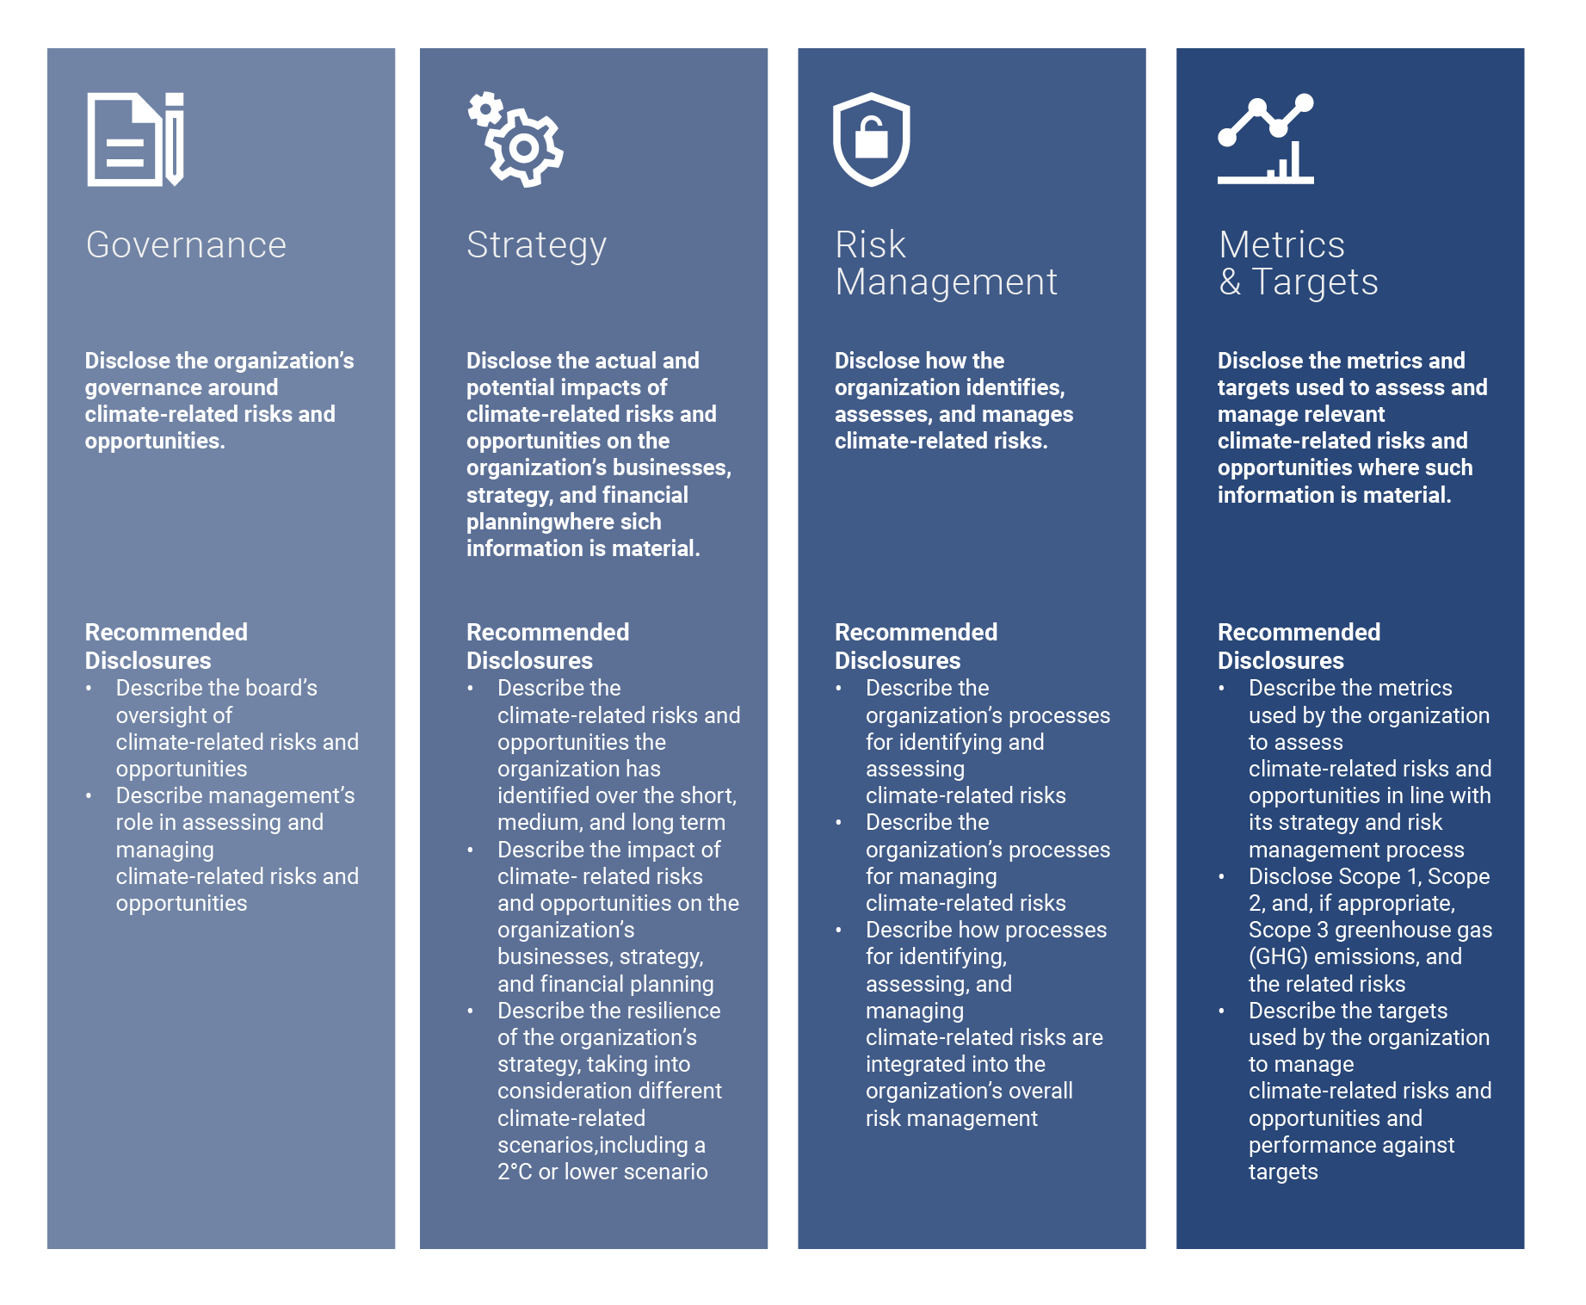

- Annex II: TCFD Steering Committee description
  - Intro
A committee of investment professionals was set up to steer the TCFD implementation process. The TCFD steering committee consists of several Board and RISG members (including the CIOs equities and fixed income, in addition to the heads of equities and fixed income research). During biannual meetings, informed by the expertise and experience of all our portfolio managers, analysts and the RICC, the committee will continue to review, update and strengthen our climate change strategy and risk management process, including the review of metrics and targets and engagement on environmental concerns.
This following image and text provides an overview of the members of the TCFD steering committee and further describes its roles and responsibilities, as assigned and approved by the DPAM Management Board.
  - Members
Peter De Coensel  CEO & Chairman of the TCFD Steering Committee | Ophélie Mortier  Chief Sustainable Investment Officer | Gerrit Dubois  Responsible Investment Specialist | Jeroen Sioncke  Head of Risk Management | Koen Bosquet  Portfolio Manager Fundamental Equity
Philippe Denef  CIO Quantitative Equity & Asymmetric Management | Pierre Reymond  Risk Manager | Michael Oblin  Head of Credit Research | Ivo Dierick  Senior buy-side analyst - financials | Ronald Van Steenweghen  Portfolio Manager Fixed Income
Olivier Van Haute
Head of Global Balanced Fund Management

  - Roles & Responsibilities
In terms of mission, the TCFD Steering Committee ensures DPAM's day-to-day operational and strategic investment activities align with market evolutions, trends and best practices. In terms of vision, the committee ensures DPAM's investment activities align with its commitment to Net Zero by 2050.
As such, the TCFD Steering Committee has an advisory and operational/executive role concerning the implementation of the TCFD recommendations in DPAM’s overall investment activities. This includes the following responsibilities:
Reporting to DPAM Management Board on the implementation and integration of the TCFD recommendations. This includes:
Presenting an annual status report (status, progress and future actions, as mentioned in point 2.)
Presenting a bi-annual asset allocation overview (exposure) and NZAM status (including financed emissions), and in case required formulating appropriate recommendations.
Formulating ad-hoc recommendations to the Management Board around climate-related investment principles, initiatives, data providers and tools to facilitate the integration of the TCFD recommendations at all levels.
Formulating ad-hoc recommendations to the Management Board around metrics and target setting for portfolios and/or at DPAM level.
Evaluation and steering of the operational integration of climate-related risks and opportunities in investment decision making activities, by all actors involved (i.e. portfolio managers, analysts, risk management, value added services, RICC, sales, IPM, Voting Advisory Board). This includes:
Assessing and evaluating exposure to climate-risks at DPAM level and individual portfolio level through the use of:
- sector allocation monitoring (i.e. TCFD monitoring dashboard);
- climate performance and scenario analysis/alignment of individual portfolios (Net Zero alignment, temperature alignment, GHG emissions, etc.);
- TCFD assessments at investee level for all portfolios, with a strong focus on materiality and engagement;
- other metrics and tools, still to be defined;
Ensuring proper training of portfolio managers, analysts and all other actors involved with a strong focus on engagement.
Reporting to DPAM Voting Advisory Board on recommendations for the implementation and integration of the TCFD recommendations in DPAM’s voting activities. This includes:
Formulating ad-hoc recommendations to the Voting Advisory Board on net zero and broader climate-related proxy voting principles and best practice.
Communicating on climate-related proxy voting related escalation measures, such as the co-filing of shareholder proposals.

  - Annex III: TCFD risk and opportunities framework (link climate change and finance)
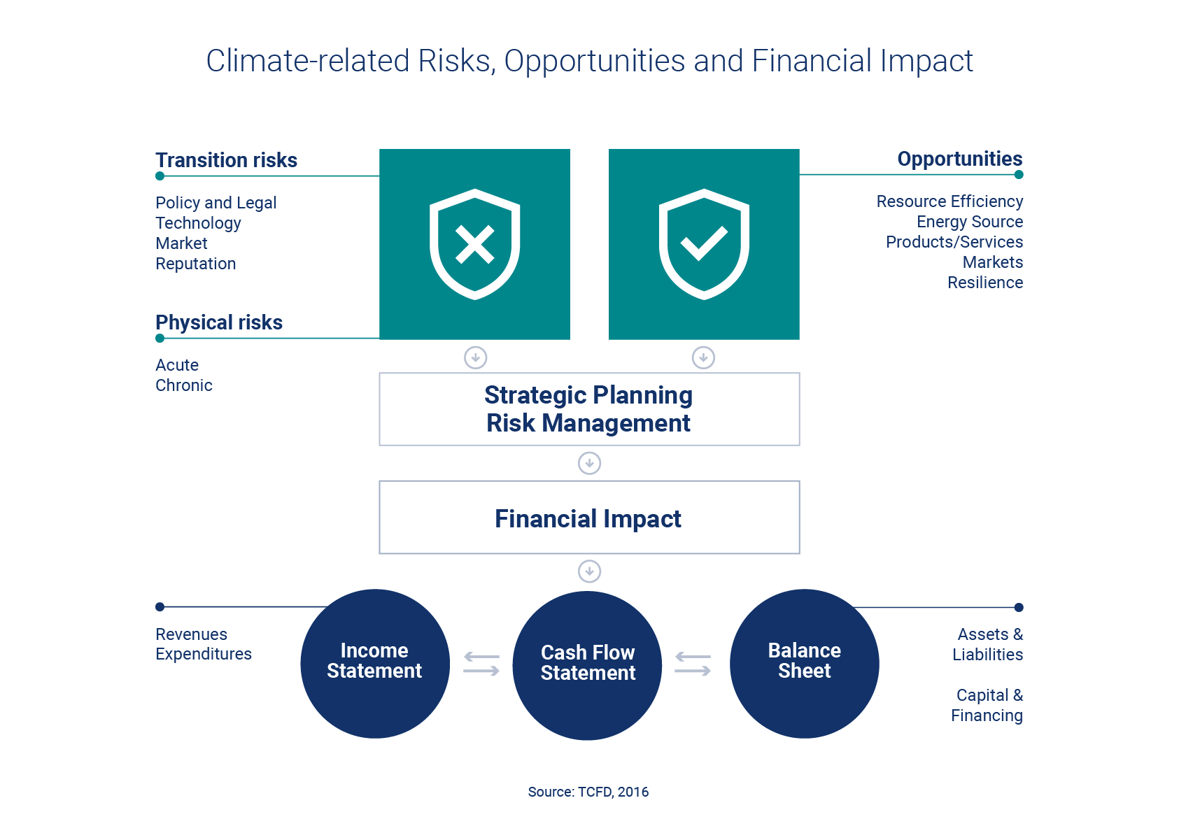
- Glossary
CA 100+ | Climate Action 100+, a collaborative engagement initiative focused on climate change.
Carbon intensity | The weighted average of the carbon intensity of the portfolio (in tCO2e/$M revenue) is meant to assess the portfolio’s carbon risk in the framework of the transition to a low-carbon economy and measures the portfolio’s exposure to high-carbon emitting issuers. The calculation method is based on the acknowledged methodology of the Global Greenhouse Protocol and takes into account the scope 1 emissions (direct emissions resulting from sources which are the property of or are controlled by the reporting issuer) and scope 2 emissions (direct emissions relating to energy use (electricity, heat, steam) required to be able to produce the product on offer).
CDP | Former Carbon Disclosure Project, a not-for-profit charity running the global disclosure system for investors, companies, cities, states and regions to manage their environmental impacts.
Climate-related opportunities | Opportunities related to the energy transition and society’s measures to mitigate the causes of climate change. Four main categories of climate-related opportunities can be identified: resource efficiency, energy source, products/services, markets and resilience.
Climate-related physical risks | Risks which arise as a consequence of climate change (due to the emission of greenhouse gases in the atmosphere). Two categories of climate-related physical risks can be identified: acute risks and chronic risks.
Climate-related transition risks | Risks which arise due to society’s measures to mitigate the causes of climate change (i.e. greenhouse gas emissions in the atmosphere). Four main categories of climate-related transition risk can be identified: policy and legal risk, technology risk, market risk and reputation risk.
EU Emissions Trading Scheme (ETS) | Carbon market for the EU based on a cap-and-trade system with the aim of reducing greenhouse gas emissions in the EU.
EU Green Deal | Europe’s new growth strategy that aims to transform the EU into a fair and prosperous society, with a modern, resource-efficient and competitive economy where there are no net emissions of greenhouse gases in 2050 and where economic growth is decoupled from resource use.
GFANZ | Glasgow Financial Alliance for Net Zero
Global Carbon Project (GCP) | GCP is a Global Research Project of Future Earth and a research partner of the World Climate Research Programme and integrates knowledge of greenhouse gases for human activities and the Earth system.
FAIRR | Farm Animal Investment Risk and Return; collaborative investor network that raises awareness of the environmental, social and governance (ESG) risks and opportunities brought about by intensive livestock production.
Financial Stability Board | An international body that monitors and makes recommendations about the global financial system. It was established after the G20 London summit in April 2009 as a successor to the Financial Stability Forum
IEA | International Energy Agency a Paris-based autonomous intergovernmental organization established in the framework of the Organisation for Economic Co-operation and Development (OECD) in 1974. It acts as a policy adviser to its member states, but also works with non-member countries. The IEA has a broad role in promoting alternate energy sources (including renewable energy), rational energy policies, and multinational energy technology co-operation.
IPCC | Intergovernmental Panel on Climate Change (IPCC) is a United Nations body dedicated to providing the world with objective, scientific information relevant to understanding the scientific basis of the risk of human-induced climate change, its natural, political, and economic impacts and risks, and possible response options.
RICC | Responsible Investment Competence Center
RISG | Responsible Investment Steering Group-
SBTi  Scenario analysis | Science-Based Targets initiative  Scenario analysis is a tool to enhance critical strategic thinking, a way to challenge conventional wisdom about the future and an intention to explore alternatives that may significantly alter the basis for “business-as-usual” assumptions. By applying scenario analysis on different climate-related risks, an investor could make more-informed investment decisions and tackle the degree of uncertainty which is inherent to climate-related risks and opportunities.
TCFD | Task force on Climate-related Financial Disclosures
WEF | World Economic Forum






Contact
Details
Ophélie Mortier
Chief Sustainable
Investment Officer
o.mortier@degroofpetercam.com
Tel + 32 2 287 97 01
www.dpaminvestments.com
/company/dpam
dpam@degroofpetercam.com
Blog: https://shorturl.at/nzJPS

Disclaimer
The information contained in this document and its attachments (hereafter the “documents”) is provided for pure information purposes only.
These documents do not represent an investment advice and do not form part of an offer or solicitation for shares, bonds or mutual funds, or an invitation to buy or sell the products or instruments referred to herein.
Applications to invest in any fund referred to in this document can only validly be made on the basis of the key information document (KID), the prospectus and the latest available annual or semi-annual reports. These documents can be obtained free of charge from Degroof Petercam Asset Management sa, the financial service provider and on the website of the sub-fund at www.dpamfunds.com.
All opinions and financial estimates herein reflect a situation on the date of preparation of these documents and are therefore subject to change at any time without prior notice. Specifically, past performance is not necessarily indicative of future performance and there is no guarantee it will be repeated.
Degroof Petercam Asset Management nv (DPAM), with registered office at Rue Guimard 18, 1040 Brussels, and which is the author of the present document, has made its best efforts in the preparation of this document and is acting in the best interests of its clients, yet without carrying any obligation to achieve any result or performance whatsoever. The information provided is from sources which DPAM believes to be reliable. However, DPAM does not guarantee that the information is accurate or complete.
These documents may not be duplicated, in whole or in part, or distributed to other persons without the prior written consent of DPAM. These documents may not be distributed to retail investors and are solely restricted to institutional investors.
DPAM SA - Rue Guimard 18 | 1040 Brussels | Belgium

GFANZ refers to the Glasgow Financial Allianze for Net Zero, a coalition of leading financial institutions committed to accelerating the net-zero transition. For more info please refe rto https://www.gfanzero.com/.
Climate Action 100+ is an international, PRI-backed initiative led by investors to engage systemically with important greenhouse gas emitters (100+) to improve climate change governance, curb emissions, and strengthen climate-related financial disclosures. The aim of the engagement is to drive the energy transition and help achieve the goals of the Paris Agreement (http://www.climateaction100.org/).

